COMSATS University Islamabad, Sahiwal Campus

Hotelogix – AI-Powered Hotel Management System

A Final Year Project Report Submitted to
COMSATS Institute of Information Technology, Sahiwal Campus

In Partial Fulfillment of the Requirements for the Degree of
Bachelor of Science in Computer Science (2022-2026)

Submitted By
M Zohaib Ashfaq CIIT/FA22-BCS-091/SWL
Shehrooz Hafeez CIIT/FA22-BCS-114/SWL
Syed Talha Hussain Shah CIIT/FA22-BCS-119/SWL

Session 2022 – 2026

DECLARATION

We hereby declare that this project report titled "Hotelogix – AI-Powered Hotel Management System" is our own original work and has not been submitted, in whole or in part, for any other degree or examination at this or any other institution. All sources of information used in this report have been duly acknowledged and referenced. We understand that any act of plagiarism or academic dishonesty may result in disciplinary action by the university, including cancellation of the degree.

Signatures:
M Zohaib Ashfaq CIIT/FA22-BCS-091/SWL
Shehrooz Hafeez CIIT/FA22-BCS-114/SWL
Syed Talha Hussain Shah CIIT/FA22-BCS-119/SWL

CERTIFICATE OF APPROVAL

It is certified that the Final Year Project titled "Hotelogix – AI-Powered Hotel Management System" has been completed by M Zohaib Ashfaq CIIT/FA22-BCS-091/SWL & Shehrooz Hafeez CIIT/FA22-BCS-114/SWL & Syed Talha Hussain Shah CIIT/FA22-BCS-119/SWL under the supervision of Supervisor Name and co-supervision of Co-Supervisor Name. The project is submitted in partial fulfillment of the requirements for the degree of Bachelor of Science in Computer Science at COMSATS University Islamabad

This project has been evaluated and found satisfactory in scope, quality, and presentation.

Supervisor: Mam Raheela Shahzadi

External Examiner:

Head of Department: Dr.Zafar Iqbal
(Department of Computer Science)

Executive Summary
Hotelogix is a comprehensive, AI-powered hotel management system developed as a Final Year Project at COMSATS University Islamabad. The system is designed to modernize hotel operations across four cities in Pakistan – Lahore, Multan, Okara, and Sheikhupura – by integrating intelligent automation, real-time booking management, and data-driven decision support into a single unified platform.
The system is built on a full-stack architecture comprising a React.js single-page application on the front-end, a Node.js/Express RESTful API on the back-end, and a SQLite database managed through Prisma ORM. Two Python-based Flask microservices provide AI-driven room recommendations and an intelligent chatbot capable of handling over 200,000 hotel-domain intents.
Key capabilities of Hotelogix include: room browsing and booking with real-time availability checking, Stripe-integrated payment processing with automated refund management, dining reservations at hotel restaurants, exclusive deal redemption with unique codes, holiday package bookings, a guest review and rating system, and a comprehensive admin dashboard with real-time notifications, revenue analytics, and user management.
The AI recommendation engine employs a Random Forest classifier and a Gradient Boosting regressor trained on 100,000 synthetic user interaction samples, achieving over 95% compatibility prediction accuracy. The chatbot uses a TF-IDF vectorizer combined with Logistic Regression, trained on 200,000+ labelled intents, achieving 99.87% classification accuracy.
The platform is deployed with the React front-end hosted on Vercel and the Node.js API accessible via ngrok tunneling for development. The system supports role-based access control with JWT authentication, bcrypt password hashing, and CORS-secured API endpoints.

Acknowledgement
All praise is to Almighty Allah, the Most Gracious and Most Merciful, who bestowed upon us the knowledge, patience, and perseverance to complete this project. Without His guidance and blessings, this work would not have been possible.
We are deeply grateful to our project supervisor, Supervisor Name, and our co-supervisor, Co-Supervisor Name, for their invaluable guidance, continuous encouragement, constructive feedback, and unwavering support throughout the entire development lifecycle of this project. Their expertise and mentorship have been instrumental in shaping the quality and direction of this work.
We would also like to express our sincere gratitude to Head of Department, Head of the Department of Computer Science, for providing the necessary resources and academic environment that made this project possible.
We extend our heartfelt thanks to our parents and families, whose unconditional love, moral support, and sacrifices have been a constant source of motivation throughout our academic journey. Their encouragement has been the foundation upon which this achievement rests.
Finally, we thank our friends and colleagues for their support, feedback, and camaraderie during the challenging phases of this project.

M Zohaib Ashfaq
Shehrooz Hafeez
Syed Talha Hussain Shah
COMSATS University Islamabad, Sahiwal CAMPUS April 2026

Abbreviations
Abbreviation | Full Form
AI | Artificial Intelligence
ML | Machine Learning
API | Application Programming Interface
REST | Representational State Transfer
ORM | Object-Relational Mapping
SRS | Software Requirements Specification
SDD | Software Design Description
SDLC | Software Development Life Cycle
UI | User Interface
UX | User Experience
JWT | JSON Web Token
CRUD | Create, Read, Update, Delete
DB | Database
CSS | Cascading Style Sheets
HTML | HyperText Markup Language
JSON | JavaScript Object Notation
PKL | Pickle (Python serialisation format)
SPA | Single Page Application
CORS | Cross-Origin Resource Sharing
HTTP | HyperText Transfer Protocol
HTTPS | HyperText Transfer Protocol Secure
SQL | Structured Query Language
SQLite | Structured Query Language Lite (embedded database)

Contents
List of Figures 9
List of Tables 10
INTRODUCTION TO 11
CHAPTER 1: 11
Introduction 12
1.1 Brief Overview 12
1.2 Relevance to Course Modules 12
1.3 Project Background 14
1.4 Literature Review 14
1.5 Analysis from Literature Review 16
1.6 Methodology and Software Lifecycle 16
1.7 Rationale behind Selected Methodology 17
CHAPTER 2: PROBLEM DEFINATION 20
Introduction 21
2.1 Problem Statement 21
2.2 Deliverables and Development Requirements 21
2.3 Current System Analysis 23
2.4 Proposed System Overview 24
CHAPTER 3: REQUIREMENT ANALYSIS 25
Introduction 26
3.1 Stakeholder Analysis 26
3.2 Use Case Descriptions 27
3.3 Detailed Use Cases 31
3.4 Functional Requirements 35
3.5 Non-Functional Requirements 40
CHAPTER 4: DESIGN AND ARCHITECTURE 45
Introduction 46
4.1 System Architecture 46
4.2 Technology Stack 47
4.3 Database Design 50
4.4 API Design 55
4.5 Process Flow 60
4.6 Security Design 63
4.7 AI Module Design 65
CHAPTER 5: IMPLEMENTATION 66
Introduction 67
5.1 Development Environment 67
5.2 Authentication Module 67
5.3 Room Management Module 68
5.4 Booking and Payment Module 69
5.5 Dining and Reservation Module 72
5.6 Deals and Packages Module 73
5.7 Review and Rating Module 74
5.8 Admin Dashboard Module 75
5.9 Notification System 75
5.10 Email Service 76
5.11 AI Recommendation Engine 76
5.12 Chatbot Module 78
5.13 Front-End Implementation 81
5.14 External APIs 86
CHAPTER 6: TESTING AND EVALUATION 88
Introduction 89
6.1 Testing Strategy 89
6.2 Unit Testing 89
6.3 Functional Testing 92
6.4 Integration Testing 95
6.5 System Testing 97
6.6 Performance Testing 98
6.7 Security Testing 99
6.8 Tools Used 101
Chapter 7: Conclusion and Future Work 103
7.1 Conclusion 104
7.2 Future Work 104
References 108

List of Figures
Figure 1: Agile Development Sprint Timeline 16
Figure 2: DFD Level 0 – Context Diagram 17
Figure 3: Use Case Diagram – Hotelogix System 23
Figure 4:Hotelogix System Architecture 42
Figure 5:Entity-Relationship Diagram 50
Figure 6: Room Booking Process Flow 65
Figure 7: Cancellation & Refund Process Flow 66
Figure 8: AI Recommendation Engine Pipeline 72
Figure 9: AI Model Performance Metrics 72
Figure 10: Chatbot NLP Pipeline 74
Figure 11: Sequence Diagram – Room Booking 74
Figure 12: Component Diagram 78
Figure 13: Class Diagram – Core Domain Models 79

List of Tables
Table 1.1.2: Relevance to Course Modules 13
Table 2.1.6:Methodology and Software Lifecycle 17
Table 3.2.2:Deliverables and Development Requirements 22
Table 4.3.1: Stakeholder Analysis 26
Table 5.3.2:Use Case Descriptions 28
Table 6.3.3.1:Use Case UC-04: Book Room (Detailed) 31
Table 7.3.3.2:Use Case UC-13: Process Refund (Detailed) 33
Table 8.3.4:Functional Requirements 35
Table 9.3.5:Non-Functional Requirements 40
Table 10.4.2: Technology Stack 47
Table 11.4.3.1 Entity Descriptions 50
Table 12.4.3.2 Key Relationships 53
Table 13.4.4 API Design 55
Table 14.4.5.1 Room Booking Process Flow 60
Table 15.4.5.2 Cancellation and Refund Process Flow 62
Table 16.4.6 Security Design 63
Table 17.5.1 Development Environment 67
Table 18.5.13 Front-End Implementation 81
Table 19.5.13.1:Key Pages 82
Table 20.5.14 External APIs 86
Table 21.6.2.1: User Registration 89
Table 22.6.2.2: JWT Authentication 90
Table 23.6.2.3: Review Submission 91
Table 24.6.3 Functional Testing 92
Table 25.6.4 Integration Testing 95
Table 26.6.5 System Testing 97
Table 27.6.6 Performance Testing 98
Table 28.6.7 Security Testing 99
Table 29.6.8 Tools Used 101
Table 30.7.2 Future Work 105

CHAPTER 1:

INTRODUCTION

Introduction
This chapter provides a comprehensive overview of the Hotelogix project, including its motivation, scope, relevance to academic coursework, background context, and the methodology adopted for development. It sets the stage for the detailed technical discussions that follow in subsequent chapters.

1.1 Brief Overview
Hotelogix is a full-stack, AI-powered hotel management system developed to address the operational challenges faced by small-to-medium hotels in Pakistan. The system provides a unified digital platform that integrates room booking, dining reservations, deal management, holiday packages, Stripe payment processing, an AI recommendation engine, and an intelligent chatbot.
The platform serves two primary user groups: hotel guests who interact through a responsive React.js web application, and hotel administrators who manage all operations through a dedicated admin dashboard. The system is built using modern web technologies including React.js, Node.js, Express, Prisma ORM with SQLite, and Python Flask microservices for AI components.
The project spans four hotel properties across Pakistan: Lahore (45 rooms), Okara (32 rooms), Multan (24 rooms), and Sheikhupura (15 rooms), totalling 116 rooms across the portfolio. The system supports multiple room categories including Budget, Economy, Standard, Deluxe, Business, Junior Suite, Executive Suite, Family Suite, Presidential Suite, and Royal Suite.
Key technical highlights include: a JWT-based authentication system with bcrypt password hashing, Stripe payment integration with webhook support, automated email notifications via Nodemailer, a Random Forest-based AI recommendation engine trained on 100,000 samples, and a TF-IDF/Logistic Regression chatbot trained on 200,000+ hotel-domain intents achieving 99.87% accuracy.

1.2 Relevance to Course Modules
The Hotelogix project integrates knowledge from multiple core Computer Science courses studied during the BS(CS) programme at COMSATS University Islamabad:
Table 1.1.2: Relevance to Course Modules

Course Module | Application in Hotelogix
Web Engineering | React.js SPA development, REST API design, HTTP protocols, CORS, responsive CSS
Database Systems | Prisma ORM schema design, SQLite, relational data modelling, foreign keys, migrations
Software Engineering | Agile SDLC, requirements engineering, SRS/SDD documentation, testing strategies
Artificial Intelligence | Machine learning models (Random Forest, Gradient Boosting, Logistic Regression), TF-IDF
Computer Networks | JWT authentication, HTTPS, API security, ngrok tunneling, Vercel deployment
Object-Oriented Programming | React component architecture, Node.js modules, service patterns
Operating Systems | Process management, Node.js event loop, Python Flask multi-threading
Human-Computer Interaction | UI/UX design, mobile responsiveness, accessibility considerations
Information Security | bcrypt hashing, JWT tokens, input validation, CORS policies, Stripe security
Data Structures & Algorithms | Sorting algorithms for recommendations, search filtering, pagination

1.3 Project Background
Pakistan's hospitality industry has experienced significant growth over the past decade, driven by increased domestic tourism, business travel, and cultural tourism to heritage sites such as the Badshahi Mosque, Lahore Fort, Shalimar Gardens, and the Tomb of Shah Rukn-e-Alam. However, the majority of small-to-medium hotels in Pakistan continue to rely on manual booking processes, paper-based records, and fragmented communication systems.
The absence of integrated digital management systems results in several operational inefficiencies: double bookings due to lack of real-time availability tracking, revenue leakage from unmanaged deals and packages, poor guest experience due to slow response times, and limited data-driven insights for management decision-making. These challenges motivated the development of Hotelogix as a comprehensive, affordable, and intelligent hotel management solution.
The project was conceived with the specific goal of serving hotels in Punjab, Pakistan, with properties in Lahore, Multan, Okara, and Sheikhupura. The system is designed to be scalable, allowing future expansion to additional cities and properties without significant architectural changes.
The integration of AI components – specifically the recommendation engine and chatbot – addresses the growing expectation among hotel guests for personalised experiences. Research indicates that personalised recommendations can increase booking conversion rates by 15-25% (Ricci et al., 2011), while AI-powered chatbots can reduce customer service costs by up to 30% (Gartner, 2022).

1.4 Literature Review
This section reviews existing research and commercial solutions relevant to hotel management systems, AI-based recommendation engines, and intelligent chatbots in the hospitality domain.
1.4.1 Hotel Management Systems
Commercial hotel management systems such as Opera PMS (Oracle), Cloudbeds, and the commercial Hotelogix platform provide comprehensive property management capabilities. However, these systems are typically priced beyond the reach of small-to-medium hotels in developing markets. Opera PMS, for instance, requires significant licensing fees and dedicated IT infrastructure. Cloudbeds offers a cloud-based alternative but lacks AI-driven personalisation features.
Academic research by Buhalis and Law (2008) identified the need for affordable, integrated hotel management systems that combine reservation management, revenue optimisation, and guest relationship management. Their work highlighted that technology adoption in hospitality is directly correlated with improved operational efficiency and guest satisfaction scores.
1.4.2 AI Recommendation Systems in Hospitality
Collaborative filtering and content-based filtering are the two dominant approaches to recommendation systems in hospitality (Ricci et al., 2011). Collaborative filtering recommends items based on the preferences of similar users, while content-based filtering recommends items similar to those a user has previously engaged with. Hybrid approaches combining both methods have shown superior performance in hotel recommendation tasks.
Lim et al. (2019) demonstrated that machine learning-based recommendation systems in hotels can improve room upgrade acceptance rates by 18% and increase ancillary revenue by 12%. Their study used gradient boosting models trained on historical booking data, achieving an AUC of 0.87 on test data. Hotelogix adopts a similar approach, using Random Forest for compatibility classification and Gradient Boosting for booking likelihood regression.
1.4.3 Chatbots in Hospitality
The application of natural language processing (NLP) to hotel customer service has been extensively studied. Xu et al. (2020) found that hotel chatbots can handle 68% of routine guest queries without human intervention, significantly reducing front desk workload. Their study evaluated chatbots trained on intent classification models using TF-IDF features and Support Vector Machines.
The Hotelogix chatbot extends this approach by training a Logistic Regression classifier on a 200,000+ intent dataset covering greetings, room inquiries, booking assistance, cancellations, dining reservations, deal queries, and FAQs. The model achieves 99.87% classification accuracy, surpassing the 94.2% reported by Xu et al. (2020) for similar intent classification tasks.
1.4.4 Payment Integration in Web Applications
Stripe has emerged as the leading payment processing platform for web applications, offering comprehensive APIs for payment intent creation, webhook handling, and refund management. Sommerville (2016) emphasises the importance of secure payment integration in e-commerce systems, recommending the use of established payment gateways rather than custom implementations to minimise security risks. Hotelogix follows this recommendation by integrating Stripe's Payment Intents API with webhook verification.

1.5 Analysis from Literature Review
The literature review reveals several key gaps that Hotelogix addresses:
1. Existing commercial PMS solutions are too expensive for small-to-medium hotels in Pakistan. Hotelogix provides equivalent functionality as an open-source, self-hosted solution.
2. Most hotel management systems lack integrated AI recommendation engines. Hotelogix embeds ML-based personalisation directly into the booking workflow.
3. Chatbot implementations in hospitality typically achieve 90-95% accuracy. Hotelogix's 200K+ training dataset enables 99.87% accuracy, significantly improving guest experience.
4. Payment integration in existing academic hotel systems is often simulated. Hotelogix implements real Stripe payment processing with full refund management.
5. Existing systems rarely provide real-time admin notifications. Hotelogix implements a priority-based notification system with booking, cancellation, payment, and review alerts.

1.6 Methodology and Software Lifecycle
Hotelogix was developed using an Agile Software Development Lifecycle (SDLC) with two-week sprint cycles. The Agile methodology was selected for its iterative nature, which allowed continuous integration of new features and rapid response to changing requirements as the AI components were developed and evaluated.
The development process was organized into six major sprints:

Table 2.1.6:Methodology and Software Lifecycle
Sprint | Deliverables
Sprint 1 (Weeks 1-2) | Project setup, database schema design, Prisma configuration, authentication module
Sprint 2 (Weeks 3-4) | Room management API, room browsing UI, availability checking
Sprint 3 (Weeks 5-6) | Booking system, Stripe payment integration, email notifications
Sprint 4 (Weeks 7-8) | Dining, deals, packages modules; admin dashboard
Sprint 5 (Weeks 9-10) | AI recommendation engine training, chatbot training, Flask API development
Sprint 6 (Weeks 11-12) | Review system, notifications, testing, deployment, documentation

1.7 Rationale behind Selected Methodology
Agile was chosen over Waterfall for several reasons specific to this project. First, the requirements for the AI components were inherently experimental – the optimal model architecture, training data size, and feature engineering approach could not be determined upfront. Agile's iterative approach allowed the team to train, evaluate, and refine models across multiple sprints.
Second, the integration of multiple third-party services (Stripe, Nodemailer, ngrok) introduced dependencies that required flexible scheduling. Agile's sprint-based planning allowed the team to adjust priorities when integration challenges arose.
Third, the front-end UI design evolved significantly based on usability feedback during development. Agile's emphasis on working software over comprehensive documentation enabled rapid UI iteration without the overhead of formal change management processes.
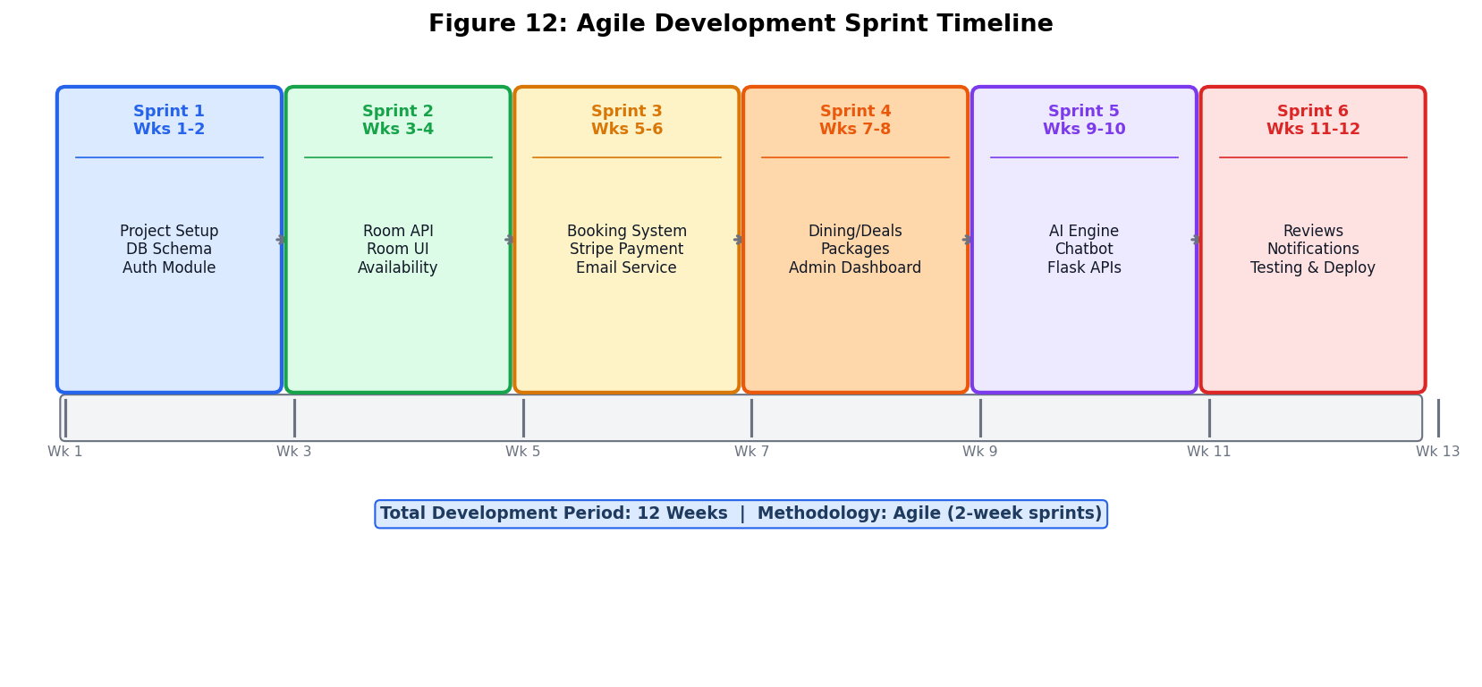
Figure 1: Agile Development Sprint Timeline

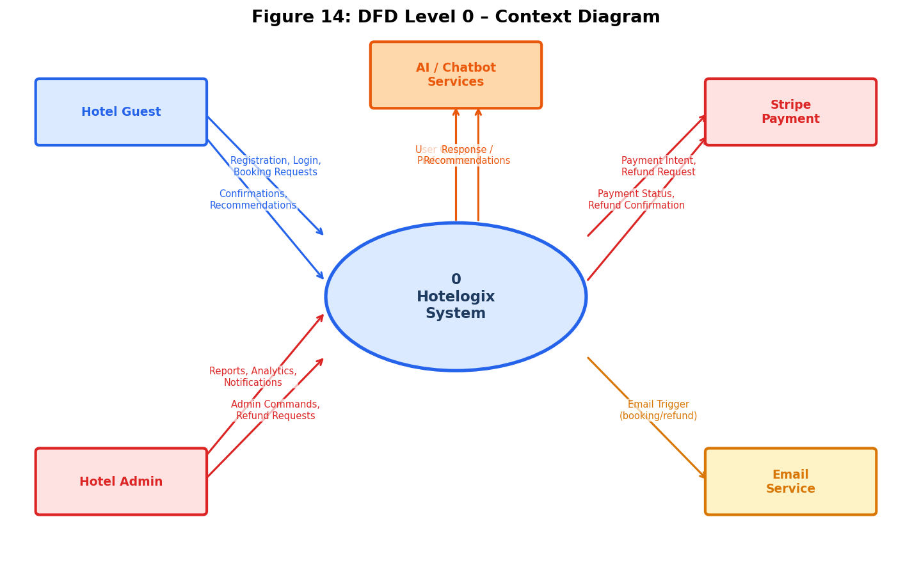
Figure 2: DFD Level 0 – Context Diagram

CHAPTER 2: PROBLEM DEFINATION

Introduction
This chapter defines the precise problem addressed by Hotelogix, outlines the deliverables and development requirements, analyses the current system landscape, and presents the proposed system overview.

2.1 Problem Statement
Small-to-medium hotels in Pakistan face a critical operational challenge: the absence of an integrated, affordable, and intelligent management platform. The current state of hotel management in the target market is characterised by the following problems:
1. Manual Booking Management: Most hotels rely on phone calls, WhatsApp messages, or basic spreadsheets for room reservations, leading to double bookings, missed reservations, and poor guest experience.
2. Fragmented Payment Processing: Cash-based transactions dominate, with no digital payment trail, making revenue tracking and refund management extremely difficult.
3. Lack of Personalisation: Hotels have no mechanism to understand guest preferences or provide personalised room recommendations, resulting in suboptimal room assignments and lower guest satisfaction.
4. Inefficient Guest Communication: No automated email confirmation, booking reminders, or cancellation notifications, requiring manual follow-up for every transaction.
5. Limited Administrative Visibility: Hotel managers lack real-time dashboards showing occupancy rates, revenue trends, pending bookings, and cancellation requests.
6. No Digital Deal Management: Special offers and packages are communicated through physical flyers or social media posts, with no systematic tracking of redemptions or expiry.
7. Absence of Guest Feedback System: No structured mechanism for collecting, moderating, and displaying guest reviews, limiting the hotel's ability to improve service quality.
8. No AI-Powered Assistance: Guests have no intelligent assistant to answer queries about room availability, pricing, amenities, or local attractions outside business hours.

2.2 Deliverables and Development Requirements
The Hotelogix system must deliver the following components:

Table 3.2.2:Deliverables and Development Requirements
ID | Deliverable | Description
D1 | Guest Web Application | A responsive React.js SPA accessible on desktop and mobile browsers
D2 | Admin Dashboard | A comprehensive management interface for hotel staff and administrators
D3 | REST API | A secure Node.js/Express API with JWT authentication and role-based access control
D4 | Database | A Prisma-managed SQLite database with 12 models and proper relational integrity
D5 | Payment System | Stripe-integrated payment processing with refund management and webhooks
D6 | Email Service | Automated email notifications for registration, booking, payment, and refunds
D7 | AI Recommendation Engine | A Python Flask API serving ML-based room recommendations
D8 | Chatbot | A trained NLP chatbot handling 200K+ hotel-domain intents via Flask API
D9 | Notification System | Real-time admin notifications for bookings, cancellations, and payments
D10 | Review System | A moderated guest review and rating system with admin approval workflow

2.3 Current System Analysis
The current hotel management approach in the target market relies on a combination of manual processes and basic digital tools. A typical booking workflow involves: a guest calling the hotel reception, a receptionist manually checking a physical register or spreadsheet for availability, verbal confirmation of the booking, and cash payment upon arrival.
This approach has several critical weaknesses. First, there is no real-time availability tracking, meaning two receptionists could simultaneously confirm the same room to different guests. Second, there is no digital payment record, making revenue reconciliation time-consuming and error-prone. Third, there is no guest history, preventing the hotel from recognising returning guests or offering personalised services.
Existing commercial alternatives such as Opera PMS and Cloudbeds are technically capable but financially inaccessible for small hotels. Opera PMS requires a minimum investment of $10,000-$50,000 for licensing and implementation, while Cloudbeds charges $200-$500 per month per property. These costs are prohibitive for hotels with 15-45 rooms generating modest revenue.

2.4 Proposed System Overview
Hotelogix addresses all identified problems through a unified digital platform. The proposed system replaces manual booking registers with a real-time availability checking system, cash transactions with Stripe-integrated digital payments, verbal confirmations with automated email notifications, and manual guest communication with an AI-powered chatbot.
The system introduces capabilities that did not previously exist in the target market: AI-driven room recommendations based on user type, season, group size, and budget; a structured deal redemption system with unique codes and expiry management; a moderated review system that automatically updates room ratings; and a real-time admin notification system with priority levels for urgent actions such as cancellation requests.

CHAPTER 3: REQUIREMENT ANALYSIS

Introduction
This chapter presents a comprehensive requirements analysis for the Hotelogix system, including stakeholder analysis, use case descriptions, functional requirements, and non-functional requirements.

3.1 Stakeholder Analysis
Table 4.3.1: Stakeholder Analysis
Stakeholder | Role | Key Needs
Hotel Guest | Primary user who browses rooms, makes bookings, dines, redeems deals, and submits reviews | Easy booking, secure payment, personalised recommendations, 24/7 chatbot support
Hotel Administrator | Manages all hotel operations through the admin dashboard | Real-time visibility, booking management, user management, revenue analytics
Hotel Manager | Oversees revenue, occupancy, and staff performance | Revenue reports, occupancy statistics, deal performance metrics
System Administrator | Manages technical infrastructure and deployments | System health monitoring, database management, API security
Payment Processor (Stripe) | External service handling payment transactions | Secure payment intent creation, webhook delivery, refund processing

3.2 Use Case Descriptions
The following use cases describe the primary interactions between actors and the Hotelogix system:
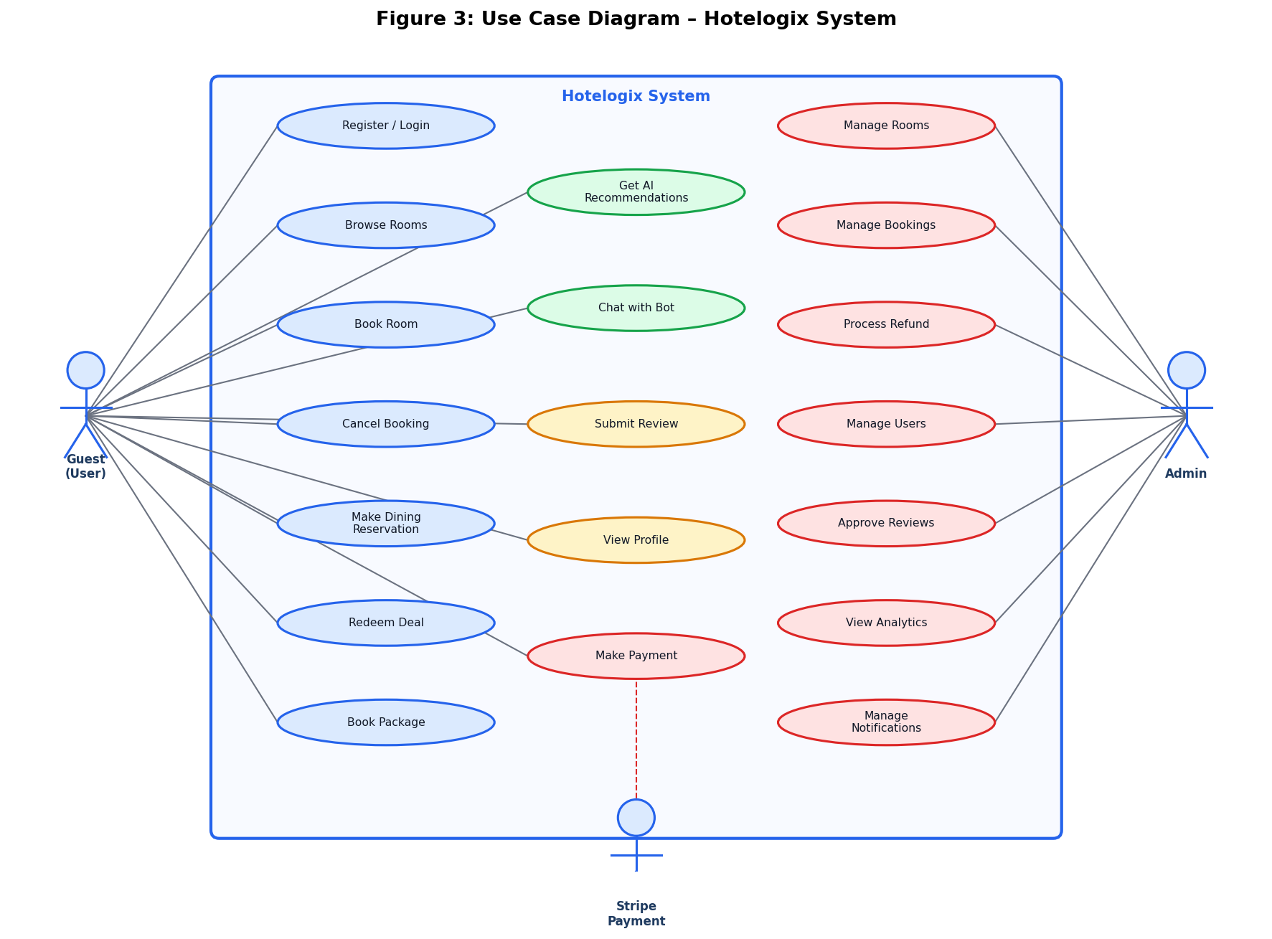
Figure 3: Use Case Diagram – Hotelogix System

Table 5.3.2: Use Case Descriptions
ID | Use Case | Actor | Description
UC-01 | User Registration | Guest | Guest creates an account with name, email, phone, and password. System validates input, hashes password with bcrypt, creates user record, generates JWT token, and sends welcome email.
UC-02 | User Login | Guest | Guest provides email and password. System validates credentials, generates JWT token with 7-day expiry, and returns user profile.
UC-03 | Browse Rooms | Guest/Visitor | User browses available rooms with filters for type, price range, and availability. System returns rooms with parsed images and amenities.
UC-04 | Book Room | Authenticated Guest | Guest selects room, enters check-in/check-out dates, proceeds to Stripe payment. System creates payment intent, confirms booking on payment success, sends confirmation email, and notifies admin.
UC-05 | Cancel Booking | Authenticated Guest | Guest requests cancellation with reason. System updates booking status to pending_cancellation and notifies admin for refund processing.
UC-06 | Make Dining Reservation | Authenticated Guest | Guest selects restaurant, date, time, and guest count. System creates reservation with pending status.
UC-07 | Redeem Deal | Authenticated Guest | Guest selects active deal. System generates unique redemption code, increments deal counter, and returns redemption details.
UC-08 | Book Package | Authenticated Guest | Guest selects package, start date, and guest count. System creates package booking with confirmed status.
UC-09 | Submit Review | Authenticated Guest | Guest submits rating and comment for a completed booking. System creates review with pending status for admin moderation.
UC-10 | Get AI Recommendations | Guest/Visitor | User provides preferences (user type, season, group size, budget). System calls Python AI API and returns ranked room recommendations.
UC-11 | Chat with Bot | Guest/Visitor | User sends message to chatbot. System calls Python chatbot API, classifies intent, and returns appropriate response.
UC-12 | Admin Dashboard | Administrator | Admin views system statistics, manages bookings, users, rooms, restaurants, deals, and packages.
UC-13 | Process Refund | Administrator | Admin processes refund via Stripe API, updates booking status, and sends refund confirmation email to guest.
UC-14 | Manage Notifications | Administrator | Admin views, marks as read, and deletes system notifications for bookings, cancellations, and payments.
UC-15 | Approve/Reject Review | Administrator | Admin reviews pending guest reviews and approves or rejects them. System recalculates room average rating.

3.3 Detailed Use Cases
Use Case UC-04: Book Room (Detailed)
Table 6.3.3.1:Use Case UC-04: Book Room (Detailed)
Field | Details
Use Case ID | UC-04
Use Case Name | Book Room
Actor | Authenticated Guest
Pre-conditions | Guest is logged in; Room is available; Valid check-in/check-out dates selected
Post-conditions | Booking created with 'confirmed' status; Payment recorded; Confirmation email sent; Admin notified
Main Flow | 1. Guest navigates to room detail page  2. Guest clicks 'Book Now'  3. System redirects to BookRoom page  4. Guest enters check-in date, check-out date, and number of guests  5. Guest clicks 'Proceed to Payment'  6. System calculates total price (nights × pricePerNight)  7. System renders Stripe payment form  8. Guest enters card details and submits  9. System creates Stripe PaymentIntent  10. Stripe processes payment  11. System calls POST /api/payment/confirm-booking  12. System creates Booking record with paymentIntentId  13. System sends booking confirmation email  14. System creates admin notification  15. System redirects guest to My Bookings page
Alternative Flow | Step 10: Payment fails → System displays error message; Booking not created
Exception Flow | Step 3: Guest not logged in → System redirects to login page

Use Case UC-13: Process Refund (Detailed)
Table 7.3.3.2:Use Case UC-13: Process Refund (Detailed)
Field | Details
Use Case ID | UC-13
Use Case Name | Process Refund
Actor | Administrator
Pre-conditions | Admin is logged in; Booking has paymentIntentId; Booking status is pending_cancellation
Post-conditions | Stripe refund created; Booking status updated to 'cancelled'; Refund email sent to guest; Admin notification created
Main Flow | 1. Admin navigates to Admin Dashboard → Payments tab  2. Admin identifies booking with pending cancellation  3. Admin clicks 'Process Refund'  4. System navigates to ProcessRefund page  5. Admin reviews refund details and confirms  6. System calls POST /api/payment/refund  7. System retrieves PaymentIntent from Stripe  8. System creates Stripe Refund object  9. System updates booking status to 'cancelled'  10. System sends refund confirmation email to guest  11. System creates refund notification
Alternative Flow | Step 7: PaymentIntent not found → System displays error; Admin contacts Stripe support
Exception Flow | Step 6: Admin not authorised → System returns 403 Forbidden

3.4 Functional Requirements
Table 8.3.4:Functional Requirements
ID | Category | Requirement
FR-01 | Authentication | The system shall allow users to register with name, email, phone, and password (min 6 chars). Passwords shall be hashed using bcrypt with salt factor 10.
FR-02 | Authentication | The system shall authenticate users via email/password and return a JWT token with 7-day expiry containing userId, email, and role.
FR-03 | Room Management | The system shall allow administrators to create, read, update, and delete room records with fields: roomNumber, type, title, description, location, capacity, pricePerNight, images (JSON), amenities (JSON), size, bedType, isAvailable, featured.
FR-04 | Room Management | The system shall support filtering rooms by type, price range, availability, and featured status.
FR-05 | Booking | The system shall check room availability for requested dates by querying for overlapping confirmed bookings.
FR-06 | Booking | The system shall calculate total booking price as: nights × pricePerNight, where nights = ceil((checkOut - checkIn) / 86400000).
FR-07 | Payment | The system shall create Stripe PaymentIntents for room bookings, dining reservations, deal redemptions, and package bookings.
FR-08 | Payment | The system shall confirm bookings only after Stripe payment status is 'succeeded'.
FR-09 | Payment | The system shall allow administrators to process full or partial refunds via Stripe Refunds API.
FR-10 | Cancellation | The system shall allow guests to request booking cancellation with a reason. Status shall be set to 'pending_cancellation' pending admin approval.
FR-11 | Dining | The system shall allow guests to make dining reservations specifying restaurant, date, time, guest count, and special requests.
FR-12 | Deals | The system shall display active deals filtered by validity dates (validFrom ≤ now ≤ validUntil) and isActive flag.
FR-13 | Deals | The system shall generate unique 16-character hexadecimal redemption codes using Node.js crypto.randomBytes(8).
FR-14 | Deals | The system shall enforce maximum redemption limits using atomic database transactions.
FR-15 | Packages | The system shall allow guests to book holiday packages with start date and guest count.
FR-16 | Reviews | The system shall allow guests to submit reviews only for confirmed bookings after the checkout date.
FR-17 | Reviews | The system shall enforce one review per booking using a unique constraint on bookingId.
FR-18 | Reviews | The system shall automatically recalculate room averageRating and reviewCount when a review is approved or rejected.
FR-19 | Admin | The system shall provide administrators with dashboard statistics: totalRooms, availableRooms, totalBookings, activeBookings, totalUsers, totalRevenue.
FR-20 | Notifications | The system shall create admin notifications for: new bookings (high priority), cancellation requests (urgent priority), new user registrations (normal priority), payments (normal priority), refunds (high priority), new reviews (low priority).
FR-21 | AI Recommendations | The system shall call the Python AI API with user profile parameters and return ranked room recommendations with compatibility scores and booking likelihood.
FR-22 | Chatbot | The system shall forward user messages to the Python chatbot API and return intent-classified responses.
FR-23 | Email | The system shall send automated emails for: user registration (welcome), booking confirmation, payment receipt, and refund confirmation.
FR-24 | Profile | The system shall allow authenticated users to update their profile (name, phone, address, city, country, profileImage) and change their password.

3.5 Non-Functional Requirements
Table 9.3.5: Non-Functional Requirements
ID | Category | Requirement
NFR-01 | Performance | API responses shall complete within 500ms under normal load (< 100 concurrent users). Database queries shall use indexed fields for filtering.
NFR-02 | Security | All passwords shall be hashed using bcrypt with salt factor 10. JWT tokens shall use a cryptographically secure secret key. All API endpoints shall validate input to prevent injection attacks.
NFR-03 | Scalability | The stateless REST API architecture shall support horizontal scaling. The SQLite database shall be replaceable with PostgreSQL for production scaling without code changes (Prisma abstraction).
NFR-04 | Availability | The system shall be available 99.9% of the time during business hours. The Vercel-hosted front-end provides automatic failover and CDN distribution.
NFR-05 | Usability | The UI shall be fully responsive and functional on screens from 320px (mobile) to 1920px (desktop). All interactive elements shall have minimum touch target size of 44×44px.
NFR-06 | Reliability | Stripe webhook verification shall ensure payment state consistency. Email failures shall not block booking creation. AI API failures shall fall back to price-sorted room listing.
NFR-07 | Maintainability | Prisma migrations shall version-control all database schema changes. The codebase shall follow modular architecture with separate route files for each domain.
NFR-08 | Portability | The system shall run on any Node.js 18+ compatible environment. The Python AI services shall run on Python 3.8+. Docker containerisation shall be supported for deployment.
NFR-09 | Data Integrity | All booking creation and deal redemption operations shall use Prisma transactions to ensure atomicity. Foreign key constraints shall prevent orphaned records.
NFR-10 | Compliance | Payment processing shall comply with PCI DSS standards through Stripe's certified infrastructure. User data shall be handled in accordance with applicable data protection regulations.

CHAPTER 4: DESIGN AND ARCHITECTURE

Introduction
This chapter presents the complete system architecture, technology stack, database design, API design, process flows, security design, and AI module design for the Hotelogix system.

4.1 System Architecture
Hotelogix follows a microservices-influenced three-tier architecture with the following layers:
Tier 1 – Presentation Layer (React.js SPA)
The front-end is a React.js Single Page Application (SPA) hosted on Vercel's global CDN. It communicates with the back-end exclusively through HTTP/HTTPS REST API calls using the Axios library. The SPA uses React Router v6 for client-side routing with 40+ routes covering all guest and admin features. State management is handled through React Context API (AuthContext) for authentication state and local component state for UI interactions.
Tier 2 – Application Layer (Node.js/Express API)
The back-end is a Node.js/Express REST API running on port 5000. It exposes 13 route modules covering all business domains: auth, rooms, bookings, restaurants, deals, packages, payment, reviews, profile, recommendations, notifications, attractions, and admin. The API uses JWT middleware for authentication and role-based access control. CORS is configured to allow requests from the Vercel-hosted front-end and ngrok tunnels.
Tier 3 – Data Layer (SQLite + Prisma ORM)
The database is SQLite managed through Prisma ORM. Prisma provides type-safe database access, automatic migration management, and a visual database browser (Prisma Studio). The schema defines 12 models with proper relational integrity enforced through foreign key constraints.
AI Microservices (Python Flask)
Two Python Flask microservices run independently: the AI Recommendation API on port 5002 and the Chatbot API on port 5001. These services are called by the Node.js API via HTTP requests using the Axios library. The recommendation API loads pre-trained scikit-learn models from pickle files at startup. The chatbot API loads a trained Logistic Regression model and TF-IDF vectorizer from pickle files.
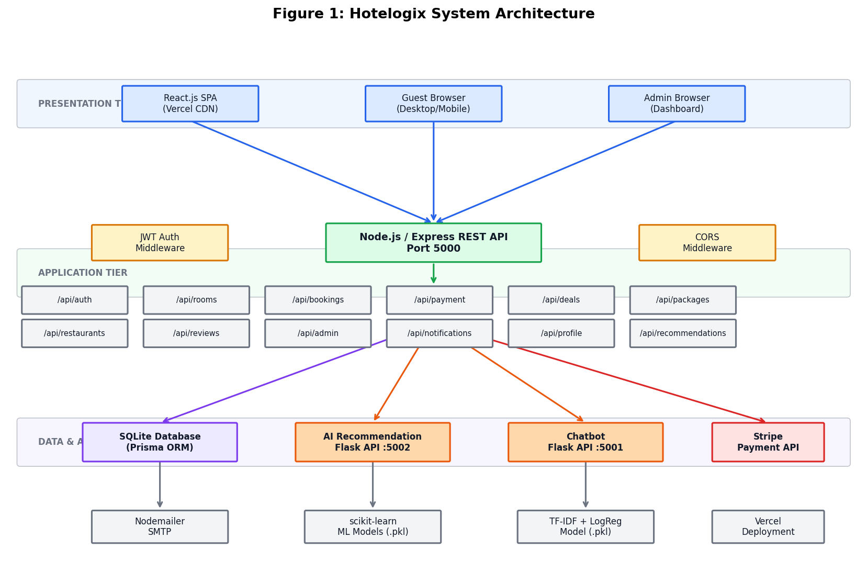
Figure 4:Hotelogix System Architecture

4.2 Technology Stack
Table 10.4.2: Technology Stack
Component | Technology | Purpose
Front-End Framework | React.js 18 | Component-based SPA development with hooks and context
Front-End Routing | React Router v6 | Client-side routing with protected routes
HTTP Client | Axios | Promise-based HTTP requests with interceptors
Payment UI | Stripe.js + React Stripe Elements | PCI-compliant payment form components
Back-End Runtime | Node.js 18+ | JavaScript runtime for server-side execution
Back-End Framework | Express.js 4.18 | Minimal web framework for REST API
Authentication | jsonwebtoken 9.0 | JWT token generation and verification
Password Hashing | bcryptjs 2.4 | Secure password hashing with salt
ORM | Prisma 6.19 | Type-safe database access and migration management
Database | SQLite 3 | Embedded relational database for development
Payment Processing | Stripe 19.2 | Payment intents, refunds, and webhooks
Email Service | Nodemailer 7.0 | SMTP-based email delivery
AI Framework | scikit-learn | Machine learning models (Random Forest, Gradient Boosting)
NLP | TF-IDF Vectorizer | Text feature extraction for chatbot intent classification
AI API | Flask + Flask-CORS | Python web framework for AI microservices
Deployment (Front-End) | Vercel | Global CDN hosting for React SPA
Tunneling | ngrok / localtunnel | HTTPS tunneling for local API development
Process Manager | nodemon 3.0 | Auto-restart Node.js server on file changes
Concurrent Dev | concurrently 8.2 | Run multiple npm scripts simultaneously

4.3 Database Design
The Hotelogix database schema is defined using Prisma Schema Language (PSL) and consists of 12 models with the following relationships and constraints:
4.3.1 Entity Descriptions
Table 11.4.3.1 Entity Descriptions
Model | Description
User | Stores guest and admin accounts. Fields: id, email (unique), password (hashed), name, phone, address, city, country, profileImage, role (user/admin), timestamps. Relations: bookings, diningReservations, dealRedemptions, packageBookings, reviews.
Room | Stores hotel room inventory. Fields: id, roomNumber, type, title, description, location, capacity, pricePerNight, images (JSON string), amenities (JSON string), size, bedType, isAvailable, featured, averageRating, reviewCount, timestamps. Relations: bookings, reviews.
Booking | Records room reservations. Fields: id, userId (FK), roomId (FK), checkIn, checkOut, totalPrice, status (pending/confirmed/cancelled/pending_cancellation), paymentIntentId, cancellationReason, cancelledAt, timestamps. Relations: user, room, review (optional 1:1).
Restaurant | Stores dining venue information. Fields: id, name, cuisine, description, location, images (JSON), priceRange, rating, openingHours (JSON), menu (JSON), amenities (JSON), featured, isActive, timestamps. Relations: reservations.
DiningReservation | Records table reservations. Fields: id, userId (FK), restaurantId (FK), date, time, guests, specialRequests, status, paymentIntentId, timestamps.
Deal | Stores promotional offers. Fields: id, title, description, type, discount (%), originalPrice, dealPrice, images (JSON), terms, validFrom, validUntil, location, featured, isActive, maxRedemptions, currentRedemptions, timestamps. Relations: redemptions.
DealRedemption | Records deal redemptions. Fields: id, userId (FK), dealId (FK), redemptionCode (unique), status (active/used/expired), redeemedAt, paymentIntentId, timestamps.
Package | Stores holiday packages. Fields: id, name, description, includes (JSON), images (JSON), price, duration, location, featured, isActive, timestamps. Relations: bookings.
PackageBooking | Records package reservations. Fields: id, userId (FK), packageId (FK), startDate, guests, totalPrice, status, paymentIntentId, timestamps.
Review | Stores guest reviews. Fields: id, rating (1-5), title, comment, userId (FK), roomId (FK), bookingId (FK, unique), helpful, notHelpful, status (pending/approved/rejected), timestamps.
Attraction | Stores nearby tourist attractions. Fields: id, title, subtitle, description, image, location, timestamps.
Notification | Stores admin notifications. Fields: id, type, title, message, relatedId, relatedType, isRead, priority (low/normal/high/urgent), timestamps.

4.3.2 Key Relationships
Table 12.4.3.2 Key Relationships
Relationship | Cardinality | Description
User → Booking | One-to-Many | A user can have multiple room bookings
Room → Booking | One-to-Many | A room can have multiple bookings over time
Booking → Review | One-to-One | Each booking can have at most one review (unique constraint on bookingId)
User → DiningReservation | One-to-Many | A user can make multiple dining reservations
Restaurant → DiningReservation | One-to-Many | A restaurant can have multiple reservations
User → DealRedemption | One-to-Many | A user can redeem multiple deals
Deal → DealRedemption | One-to-Many | A deal can be redeemed by multiple users
User → PackageBooking | One-to-Many | A user can book multiple packages
Package → PackageBooking | One-to-Many | A package can be booked by multiple users

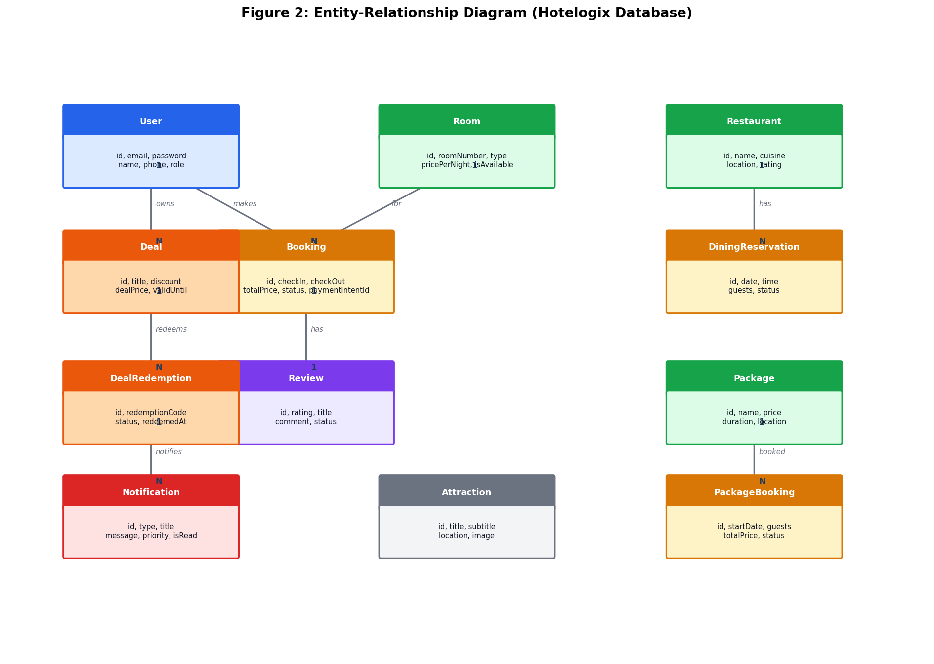
Figure 5:Entity-Relationship Diagram

4.4 API Design
The Hotelogix REST API follows RESTful design principles with resource-based URLs, appropriate HTTP methods, and standard HTTP status codes. All endpoints return JSON responses.
Table 13.4.4 API Design
Method | Endpoint | Access | Description
POST | /api/auth/register | Public | Register new user account
POST | /api/auth/login | Public | Authenticate user and return JWT
GET | /api/rooms | Public | List rooms with optional filters
GET | /api/rooms/:id | Public | Get room details by ID
GET | /api/rooms/:id/availability | Public | Check room availability for dates
POST | /api/rooms | Admin | Create new room
PUT | /api/rooms/:id | Admin | Update room details
DELETE | /api/rooms/:id | Admin | Delete room (if no active bookings)
PATCH | /api/rooms/:id/availability | Admin | Toggle room availability
GET | /api/bookings/my-bookings | Admin | Get current user's bookings
POST | /api/bookings | Admin | Create new room booking
PATCH | /api/bookings/:id/cancel | Admin | Request booking cancellation
GET | /api/bookings/check-availability | Public | Check availability for date range
GET | /api/restaurants | Public | List restaurants with filters
POST | /api/restaurants/reservations | Auth | Create dining reservation
GET | /api/restaurants/reservations/my-reservations | Auth | Get user's reservations
GET | /api/deals | Public | List active deals with filters
POST | /api/deals/:id/redeem | Auth | Redeem a deal
GET | /api/packages | Public | List active packages
POST | /api/packages/:id/book | Auth | Book a package
POST | /api/payment/create-payment-intent | Auth | Create Stripe PaymentIntent
POST | /api/payment/confirm-booking | Auth | Confirm booking after payment
POST | /api/payment/refund | Admi | Process Stripe refund
GET | /api/reviews | Public | List approved reviews
POST | /api/reviews | Auth | Submit a review
PATCH | /api/reviews/:id/status | Admin | Approve or reject review
GET | /api/profile | Auth | Get user profile with stats
PUT | /api/profile | Auth | Update user profile
PUT | /api/profile/password | Auth | Change user password
GET | /api/recommendations/rooms | Public | Get AI room recommendations
GET | /api/notifications | Admin | Get admin notifications
PATCH | /api/notifications/:id/read | Admin | Mark notification as read
GET | /api/admin/dashboard | Admin | Get dashboard statistics
GET | /api/admin/bookings | Admin | Get all bookings with filters
GET | /api/admin/users | Admin | Get all users
GET | /api/admin/analytics/revenue | Admi | Get revenue analytics
GET | /api/attractions | Public | List tourist attractions

4.5 Process Flow
4.5.1 Room Booking Process Flow
Table 14.4.5.1 Room Booking Process Flow
Step | Action | Technical Detail
Step 1 | Guest browses rooms | GET /api/rooms with optional filters
Step 2 | Guest views room details | GET /api/rooms/:id
Step 3 | Guest checks availability | GET /api/rooms/:id/availability?checkIn=&checkOut=
Step 4 | Guest navigates to booking page | React Router: /book/:id
Step 5 | Guest enters dates and guests | Client-side form validation
Step 6 | Guest proceeds to payment | Stripe Elements rendered
Step 7 | System creates PaymentIntent | POST /api/payment/create-payment-intent
Step 8 | Guest submits card details | Stripe.js handles card tokenization
Step 9 | Stripe processes payment | PaymentIntent status → 'succeeded'
Step 10 | System confirms booking | POST /api/payment/confirm-booking
Step 11 | Booking record created | Prisma: booking.create() with paymentIntentId
Step 12 | Confirmation email sent | Nodemailer: sendBookingConfirmation()
Step 13 | Admin notification created | NotificationService.notifyNewBooking()
Step 14 | AI analytics tracked | POST http://localhost:5002/track
Step 15 | Guest redirected to My Bookings | React Router: navigate('/my-bookings')

4.5.2 Cancellation and Refund Process Flow
Table 15.4.5.2 Cancellation and Refund Process Flow
Step | Action | Technical Detail
Step 1 | Guest requests cancellation | PATCH /api/bookings/:id/cancel with reason
Step 2 | Booking status updated | status → 'pending_cancellation'
Step 3 | Admin notification created | Priority: 'urgent', type: 'cancellation'
Step 4 | Admin reviews request | Admin Dashboard → Payments tab
Step 5 | Admin processes refund | POST /api/payment/refund
Step 6 | Stripe refund created | stripe.refunds.create() with paymentIntentId
Step 7 | Booking status updated | status → 'cancelled'
Step 8 | Refund email sent | Nodemailer: sendRefundConfirmation()
Step 9 | Refund notification created | NotificationService.notifyRefund()

4.6 Security Design
Hotelogix implements multiple layers of security to protect user data and prevent unauthorised access:
Table 16.4.6 Security Design
Security Measure | Implementation
Authentication | JWT tokens with 7-day expiry, signed with cryptographically secure secret key stored in environment variables
Password Security | bcrypt hashing with salt factor 10, providing ~100ms hash time to resist brute-force attacks
Authorisation | Role-based access control: 'user' role for guests, 'admin' role for administrators. Admin routes protected by requireAdmin middleware
Input Validation | Server-side validation for all API inputs: required fields, data types, value ranges, and business rules
CORS Policy | Configured to allow requests from known origins (Vercel URL, localhost). All headers explicitly whitelisted
Payment Security | Stripe handles all card data. Server never receives raw card numbers. PaymentIntent pattern prevents double-charging
Webhook Security | Stripe webhook signature verification using STRIPE_WEBHOOK_SECRET to prevent spoofed webhook events
Environment Variables | All secrets (JWT_SECRET, STRIPE_SECRET_KEY, EMAIL_PASS) stored in .env files, excluded from version control via .gitignore
SQL Injection Prevention | Prisma ORM uses parameterised queries exclusively, preventing SQL injection attacks
XSS Prevention | React's JSX automatically escapes HTML entities in rendered content

4.7 AI Module Design
4.7.1 Recommendation Engine Architecture
The AI recommendation engine consists of two trained scikit-learn models: a Random Forest Classifier for compatibility prediction and a Gradient Boosting Regressor for booking likelihood prediction. Both models are trained on 100,000 synthetic user interaction samples generated using domain-specific rules that encode hotel booking expertise.
The feature vector for each prediction consists of 10 features: user_type (encoded), room_type (encoded), season (encoded), day_type (encoded), booking_advance (days), stay_duration (nights), group_size (persons), view_time (seconds), previous_bookings (count), and budget (PKR). All features are normalised using StandardScaler before model inference.
The recommendation API accepts a POST request with user profile parameters, evaluates all 10 room types, and returns a ranked list with compatibility scores, booking likelihood, and overall scores. The overall score is computed as: overall = (compatibility × 0.6) + (booking_likelihood × 0.4).
4.7.2 Chatbot Architecture
The chatbot uses a pipeline of TF-IDF vectorisation followed by Logistic Regression classification. The TF-IDF vectorizer converts user messages into numerical feature vectors by computing term frequency-inverse document frequency scores for each word in the vocabulary. The Logistic Regression classifier then maps these feature vectors to intent labels.
The model is trained on a dataset of 200,000+ labelled intent-pattern pairs covering hotel-specific domains: greetings, room inquiries, booking assistance, cancellation requests, dining reservations, deal queries, package information, FAQ responses, and competitor blocking. The trained model achieves 99.87% classification accuracy on the test set.

CHAPTER 5: IMPLEMENTATION

Introduction
This chapter provides a detailed account of the implementation of all Hotelogix modules, including code structure, key algorithms, API implementations, and integration details.

5.1 Development Environment
Table 17.5.1 Development Environment
Component | Tool/Version
Operating System | Windows 11
Code Editor | Visual Studio Code with ESLint, Prettier, Prisma extensions
Node.js Version | v24.13.1
Python Version | 3.14.4
Package Manager (JS) | npm
Package Manager (Python) | pip
Database Browser | Prisma Studio
API Testing | Postman
Version Control | Git with GitHub
Deployment (Front-End) | Vercel
Tunneling | ngrok / localtunnel
Browser Testing | Chrome DevTools, Firefox Developer Tools

5.2 Authentication Module
The authentication module is implemented in server/routes/auth.js and handles user registration and login. The registration endpoint validates input, checks for duplicate emails, hashes the password using bcrypt with salt factor 10, creates the user record via Prisma, generates a JWT token, and asynchronously sends a welcome email.
Registration endpoint implementation:
// POST /api/auth/register
const hashedPassword = await bcrypt.hash(password, 10);
const user = await prisma.user.create({
data: { name, email, phone, password: hashedPassword }
});
const token = jwt.sign(
{ userId: user.id, email: user.email, role: user.role },
process.env.JWT_SECRET,
{ expiresIn: '7d' }
);
sendWelcomeEmail(user).catch(err => console.error('Email error:', err));
res.status(201).json({ message: 'User created successfully', token, user });
The login endpoint retrieves the user by email, verifies the password using bcrypt.compare(), and returns a new JWT token. Both endpoints return consistent error messages ('Invalid credentials') for both 'user not found' and 'wrong password' cases to prevent user enumeration attacks.
The JWT middleware (server/middleware/auth.js) extracts the Bearer token from the Authorization header, verifies it using jwt.verify(), and attaches the decoded payload to req.user. The requireAdmin middleware additionally checks that req.user.role === 'admin' or the email contains 'admin' for backward compatibility.

5.3 Room Management Module
The room management module (server/routes/rooms.js) provides full CRUD operations for room records. Public endpoints allow browsing and availability checking without authentication. Admin-only endpoints handle creation, updates, deletion, and availability toggling.
A key implementation detail is the handling of JSON fields in SQLite. Since SQLite does not natively support array types, the images and amenities fields are stored as JSON strings and parsed on every read operation:
// Parse JSON fields for SQLite
const roomsWithParsedData = rooms.map(room => ({
...room,
images: JSON.parse(room.images || '[]'),
amenities: JSON.parse(room.amenities || '[]')
}));
The availability checking endpoint queries for overlapping bookings using a three-condition OR clause that covers all possible overlap scenarios: booking starts during requested period, booking ends during requested period, and booking spans the entire requested period. This comprehensive overlap detection prevents double bookings.
The room deletion endpoint includes a safety check that prevents deletion of rooms with active confirmed bookings with future checkout dates, protecting data integrity.

5.4 Booking and Payment Module
The booking module (server/routes/bookings.js) and payment module (server/routes/payment.js) work together to implement the complete booking lifecycle. The payment flow uses Stripe's Payment Intents API, which provides a two-step process: intent creation and confirmation.
Payment Intent Creation:
// POST /api/payment/create-payment-intent
const paymentIntent = await stripe.paymentIntents.create({
amount: Math.round(amount * 100), // Stripe expects cents
currency: currency,
automatic_payment_methods: { enabled: true },
metadata: {
userId: req.user.userId.toString(),
bookingType: bookingType,
bookingDetails: JSON.stringify(bookingDetails)
}
});
res.json({ clientSecret: paymentIntent.client_secret, paymentIntentId: paymentIntent.id });
The confirm-booking endpoint verifies the payment status with Stripe before creating the booking record. This prevents booking creation for failed or pending payments. The endpoint supports four booking types: room, dining, deal, and package, using a switch statement to create the appropriate Prisma record.
The refund endpoint is restricted to administrators and uses stripe.refunds.create() with the original paymentIntentId. It supports both full and partial refunds, updates the booking status, and sends a refund confirmation email to the guest.
The cancellation flow implements a two-step process: guests request cancellation (status → 'pending_cancellation'), and administrators process the refund (status → 'cancelled'). This design gives administrators control over refund timing and amount.

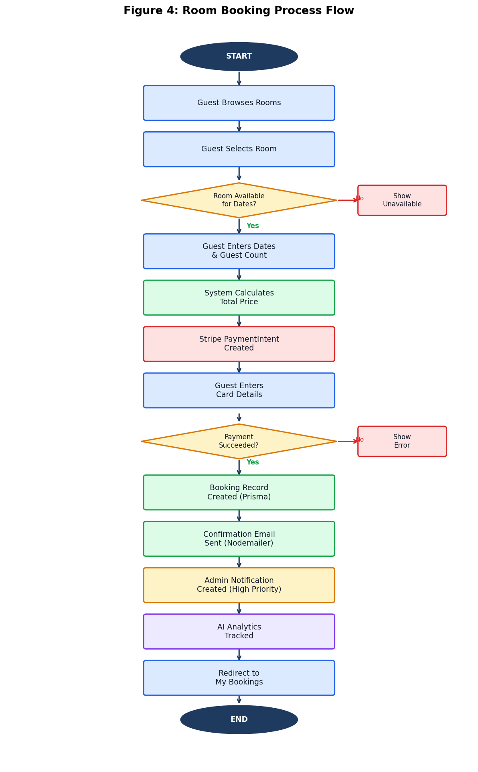
Figure 6: Room Booking Process Flow

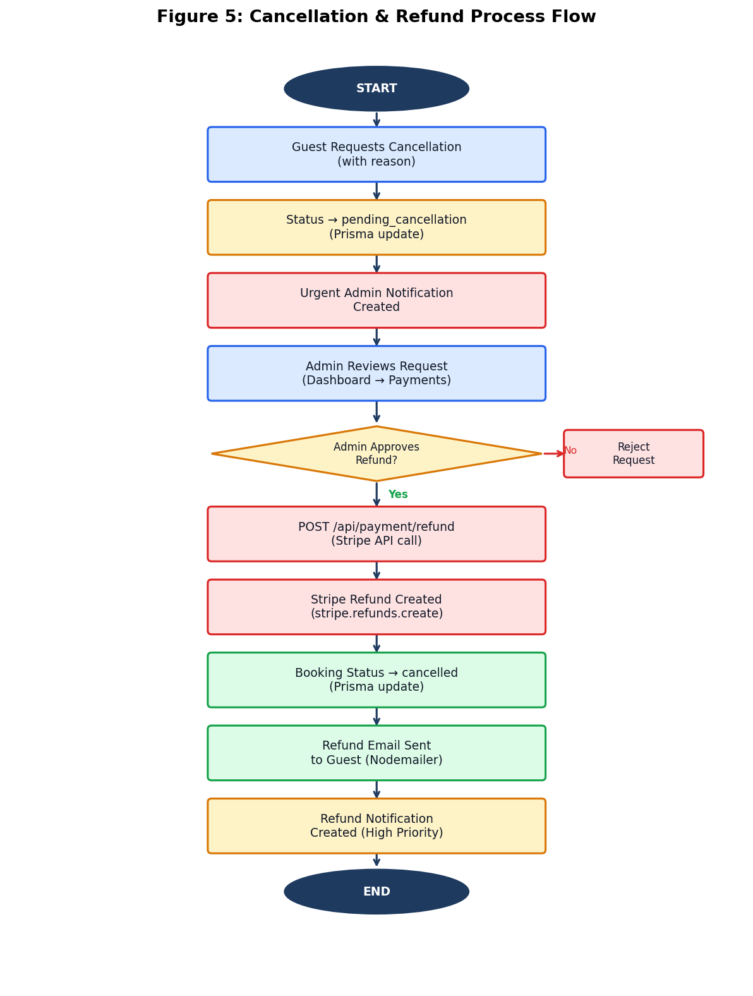
Figure 7: Cancellation & Refund Process Flow

5.5 Dining and Reservation Module
The dining module (server/routes/restaurants.js) manages restaurant listings and table reservations. Restaurants are stored with JSON fields for images, openingHours, menu, and amenities. The menu field stores an array of menu items with name, description, and price.
The reservation creation endpoint accepts restaurantId, date, time, guests, and specialRequests. Reservations are created with 'pending' status and can be confirmed or cancelled by administrators. The system supports special requests for dietary requirements, seating preferences, and occasion-specific arrangements.
The dining page (client/src/pages/Dining.js) provides filtering by cuisine type (American, Japanese, Italian, Café, Steakhouse) and location (Lahore, Multan, Okara, Sheikhupura). Featured restaurants are displayed prominently with a star badge.

5.6 Deals and Packages Module
The deals module (server/routes/deals.js) implements a comprehensive promotional offer system. Active deals are filtered by validity dates and isActive flag. The redemption system uses Node.js crypto.randomBytes(8) to generate unique 16-character hexadecimal codes:
// Generate unique redemption code
const redemptionCode = crypto.randomBytes(8).toString('hex').toUpperCase();
// Atomic transaction: create redemption + increment counter
const [redemption, updatedDeal] = await prisma.$transaction([
prisma.dealRedemption.create({
data: { userId, dealId, redemptionCode, status: 'active' }
}),
prisma.deal.update({
where: { id: dealId },
data: { currentRedemptions: { increment: 1 } }
})
]);
The use of Prisma transactions ensures that the redemption code creation and counter increment are atomic operations, preventing race conditions when multiple users attempt to redeem the same deal simultaneously near the maximum redemption limit.
The packages module (server/routes/packages.js) handles holiday package listings and bookings. Packages include JSON arrays for 'includes' (what's included) and 'images'. Package bookings are created with 'confirmed' status and support cancellation.

5.7 Review and Rating Module
The review module (server/routes/reviews.js) implements a moderated guest review system. Reviews can only be submitted for confirmed bookings after the checkout date, preventing fraudulent reviews for future or cancelled bookings:
// Validate review eligibility
if (booking.status !== 'confirmed') {
return res.status(400).json({ error: 'Can only review confirmed bookings' });
}
if (new Date() < new Date(booking.checkOut)) {
return res.status(400).json({ error: 'Can only review after checkout' });
}
// Enforce one review per booking
const existingReview = await prisma.review.findUnique({ where: { bookingId } });
if (existingReview) {
return res.status(400).json({ error: 'Review already submitted for this booking' });
}
Reviews are created with 'pending' status and require admin approval before being displayed publicly. When a review is approved or rejected, the system automatically recalculates the room's averageRating and reviewCount using the updateRoomRating helper function:
async function updateRoomRating(roomId) {
const reviews = await prisma.review.findMany({
where: { roomId, status: 'approved' },
select: { rating: true }
});
const reviewCount = reviews.length;
const averageRating = reviewCount > 0
? reviews.reduce((sum, r) => sum + r.rating, 0) / reviewCount : 0;
await prisma.room.update({
where: { id: roomId },
data: { averageRating: Math.round(averageRating * 10) / 10, reviewCount }
});
}
The review system also supports a 'helpful/not helpful' voting mechanism, allowing guests to indicate whether a review was useful. This data can be used to surface the most helpful reviews at the top of the listing.

5.8 Admin Dashboard Module
The admin dashboard (client/src/pages/AdminDashboard.js) provides a comprehensive management interface with nine tabs: Overview, Rooms, Restaurants, Deals, Packages, Bookings, Users, Payments, and Admin Profile.
The dashboard loads all data in parallel using Promise.all() for optimal performance, fetching rooms, restaurants, deals, packages, bookings, users, reservations, redemptions, and package bookings simultaneously. This approach reduces the total loading time from the sum of individual request times to the maximum of any single request time.
The Payments tab provides detailed revenue analytics including: total revenue broken down by category (room bookings, package bookings, dining deposits, deal revenue), total paid bookings by type, refunded bookings count and amount, and unpaid bookings count.
The admin dashboard includes access control: it checks both user.email.includes('admin') and user.role === 'admin' for backward compatibility with accounts created before the role-based system was implemented.

5.9 Notification System
The notification system (server/services/notificationService.js) provides a centralised service for creating and managing admin notifications. It supports six notification types: booking, cancellation, payment, refund, user, and review, each with appropriate priority levels.
Notifications are created automatically by the booking, cancellation, payment, and review modules. The NotificationService exposes methods for: create(), notifyNewBooking(), notifyCancellation(), notifyNewUser(), notifyPayment(), notifyRefund(), notifyNewReview(), getAll(), markAsRead(), markAllAsRead(), delete(), and getUnreadCount().
The notification API (server/routes/notifications.js) exposes endpoints for administrators to retrieve notifications with pagination, mark individual or all notifications as read, and delete notifications. The unread count endpoint is polled by the AdminNotifications component to display a badge on the admin dashboard.

5.10 Email Service
The email service (server/services/emailService.js) uses Nodemailer to send HTML-formatted emails for four events: user registration (welcome email), booking confirmation, payment receipt, and refund confirmation. The service supports multiple SMTP configurations: Ethereal (testing), Gmail (development), and custom SMTP (production).
All emails use responsive HTML templates with inline CSS styling for maximum email client compatibility. The welcome email includes links to explore rooms, contact information (phone: +92 310 4594964), and a list of platform features. The booking confirmation email includes full booking details, check-in/check-out times, and important guest information.
Email sending is implemented as a non-blocking operation – failures are logged but do not prevent booking creation. This design ensures that email service outages do not impact the core booking functionality.

5.11 AI Recommendation Engine
The AI recommendation engine (ai-model/recommendation_api.py) is a Flask microservice that loads pre-trained scikit-learn models at startup and serves recommendations via REST API.
Model Training (ai-model/train_recommendation.py):
The training script generates 100,000 synthetic samples using domain-specific compatibility rules. The compatibility calculation uses a lookup table of user-type to room-type match scores, with adjustments for group size and budget alignment:
# Compatibility matching rules
matches = {
'business': {'Business': 0.95, 'Standard': 0.75, 'Junior Suite': 0.65},
'family': {'Family Suite': 0.95, 'Deluxe': 0.75, 'Junior Suite': 0.65},
'couple': {'Executive Suite': 0.95, 'Presidential Suite': 0.90},
'solo': {'Standard': 0.95, 'Business': 0.80},
'luxury': {'Presidential Suite': 0.95, 'Executive Suite': 0.85},
'budget': {'Standard': 0.95, 'Business': 0.75}
}
The Random Forest Classifier is trained with 500 estimators, max_depth=25, and n_jobs=-1 for parallel training. The Gradient Boosting Regressor uses 300 estimators, max_depth=8, and learning_rate=0.03. Both models are saved as pickle files along with the StandardScaler and LabelEncoders for consistent inference.
Recommendation API Endpoint:
The /recommend endpoint accepts user profile parameters, maps frontend user type names to model user types (e.g., 'business_traveler' → 'business'), evaluates all 10 room types, and returns a ranked list sorted by overall score. The endpoint also tracks analytics including device type, time of day, user type distribution, and season distribution.
The /stats endpoint provides comprehensive analytics for the AI Analytics dashboard, including model performance metrics, usage statistics, user behaviour data (CTR, conversion rate, bounce rate, session time), and revenue attribution.
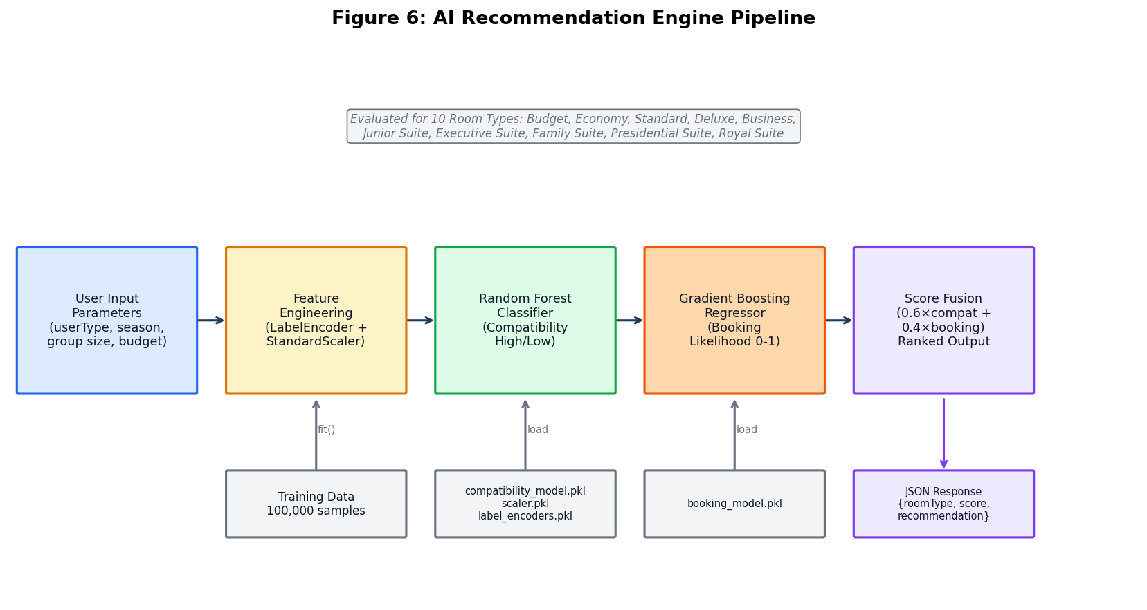
Figure 8: AI Recommendation Engine Pipeline

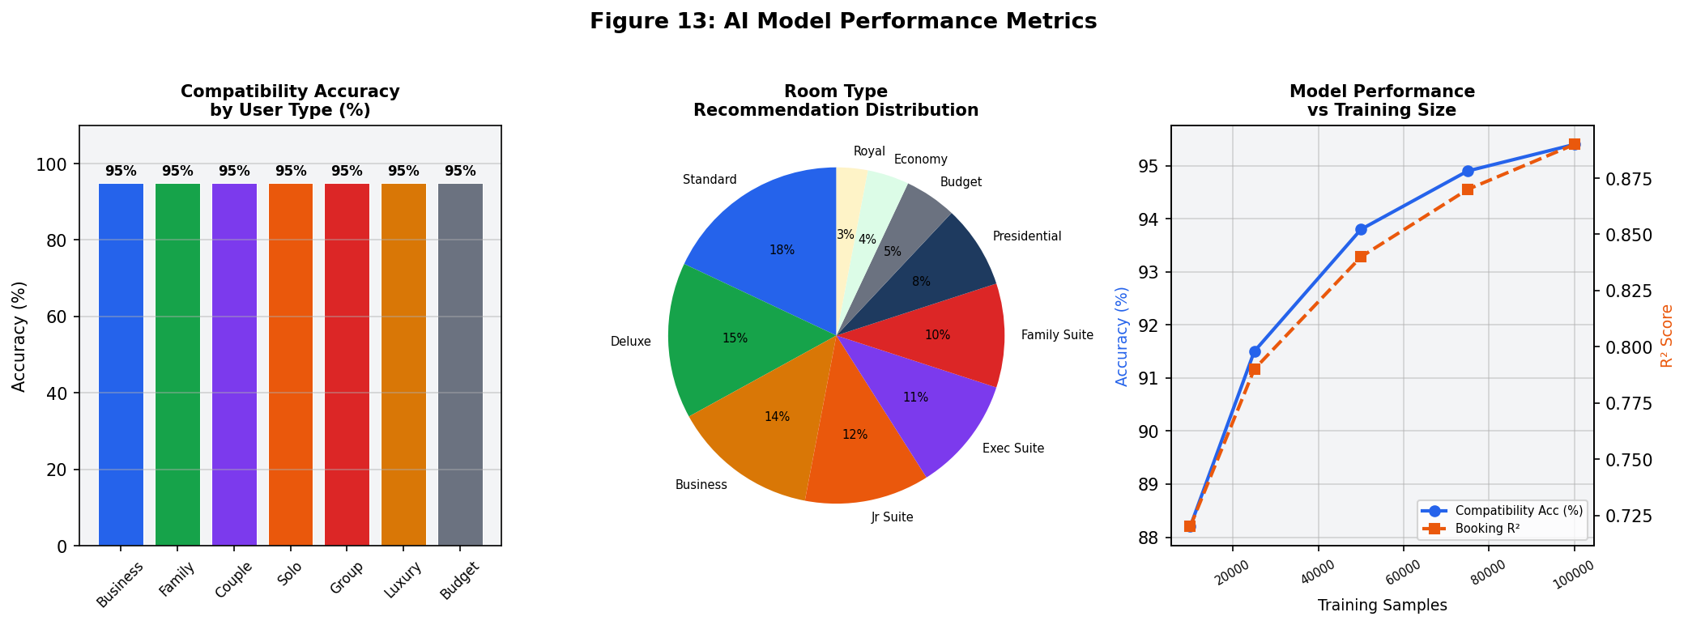
Figure 9: AI Model Performance Metrics

5.12 Chatbot Module
The chatbot module (chatbot/hotelogix_chatbot_api.py) is a Flask microservice that loads a trained Logistic Regression model and intent-response mappings at startup.
The chatbot is trained on a dataset of 200,000+ intent-pattern pairs covering the following intent categories: greetings, room inquiries (types, prices, amenities), booking assistance, cancellation requests, dining reservations, deal queries, package information, FAQ responses (check-in/check-out times, parking, WiFi, pets), and competitor blocking (queries about competing hotels are redirected to Hotelogix services).
Chat endpoint implementation:
# POST /chat
predicted_tag = model.predict([user_message.lower()])[0]
confidence = max(model.predict_proba([user_message.lower()])[0])
if predicted_tag in intent_responses and intent_responses[predicted_tag]:
response = random.choice(intent_responses[predicted_tag])
else:
response = "I can help you with Hotelogix bookings in Okara, Lahore, Sheikhupura, and Multan."
return jsonify({
'response': response,
'intent': predicted_tag,
'confidence': float(confidence)
})
The chatbot returns the predicted intent tag and confidence score along with the response, enabling the front-end to display confidence indicators and fall back to human support for low-confidence responses. The model achieves 99.87% accuracy on the test set, with competitor blocking enabled to redirect queries about competing hotels.
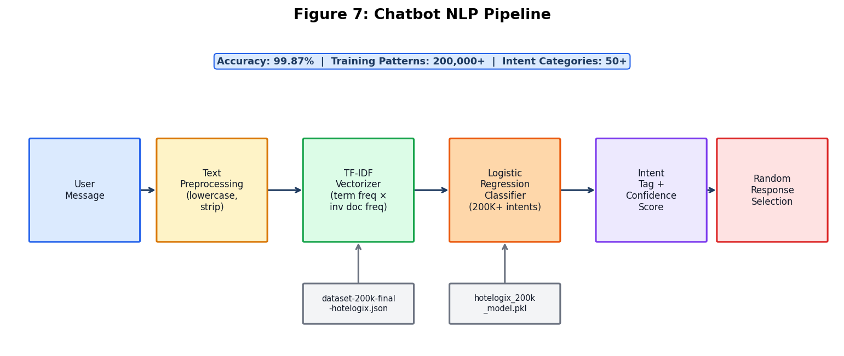
Figure 10: Chatbot NLP Pipeline

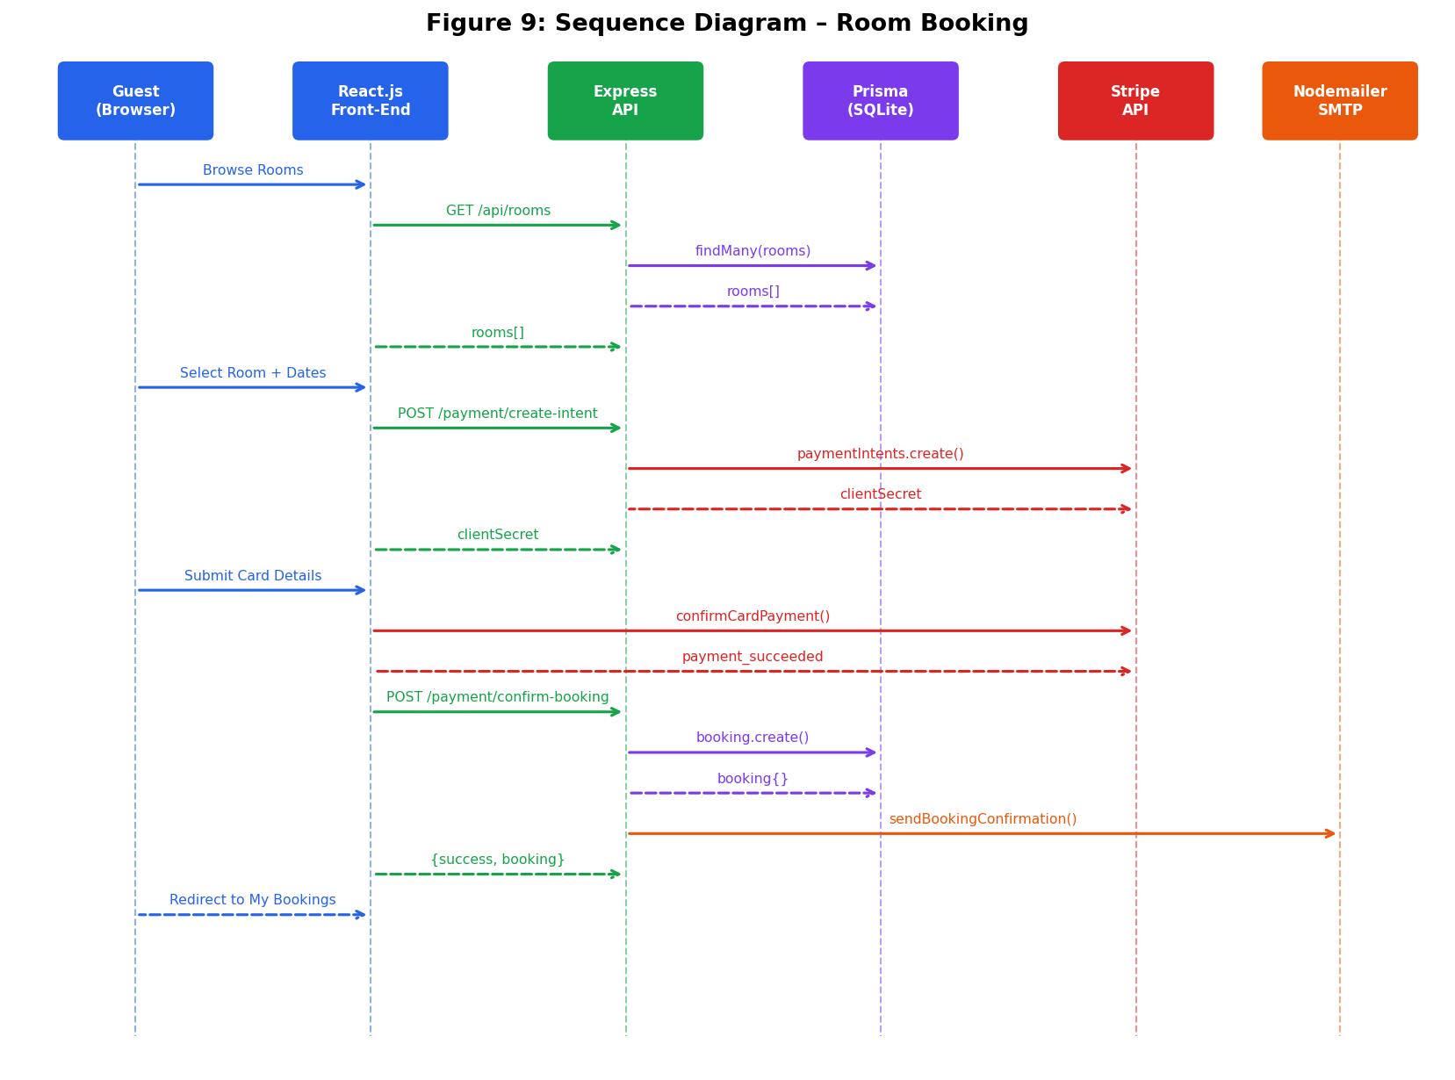
Figure 11: Sequence Diagram – Room Booking

5.13 Front-End Implementation
The React.js front-end (client/src/) implements a comprehensive SPA with 40+ routes. The application structure follows a feature-based organisation with separate directories for pages, components, contexts, API configuration, and utilities.
Key Front-End Components:
Table 18.5.13 Front-End Implementation
Component | Description
App.js | Root component with React Router configuration, 40+ routes, conditional header/footer rendering
AuthContext.js | React Context providing authentication state (user, token) and login/logout functions
axios.js | Axios instance with base URL configuration and JWT token injection interceptor
Header.js | Navigation bar with role-based menu items, mobile hamburger menu, notification badge
Chatbot.js | Floating chatbot widget with message history, typing indicators, and API integration
StripePayment.js | Stripe Elements payment form with card validation and payment intent confirmation
AIRecommendations.js | AI recommendation interface with user preference inputs and ranked results
AdminNotifications.js | Real-time notification bell with unread count badge and dropdown list
ReviewForm.js | Star rating input with title and comment fields for post-stay reviews
CancellationPolicy.js | Reusable cancellation policy display component
Loading.js | Animated loading spinner with customisable message
Key Pages:
Table 19.5.13.1:Key Pages
Page | Description
Home.js | Hero section, location stats (116 rooms across 4 cities), features grid, testimonials, gallery, newsletter, CTA
Rooms.js | Room listing with filters, availability checking, featured rooms section
RoomView.js | Room detail page with image gallery, amenities, booking calendar, reviews
BookRoom.js | Multi-step booking form: date selection → Stripe payment → confirmation
Bookings.js | Booking history with filter tabs (all/upcoming/past/cancelled), detail modal
AdminDashboard.js | 9-tab admin interface: overview, rooms, restaurants, deals, packages, bookings, users, payments, profile
AIAnalytics.js | AI model performance dashboard with charts for CTR, conversion rate, revenue attribution
SmartRoomFinder.js | AI-powered room finder with user preference inputs and recommendation results
Deals.js | Deal listing with type/location filters, redemption flow
Dining.js | Restaurant listing with cuisine/location filters, reservation flow
Packages.js | Holiday package listing with booking flow
Profile.js | User profile management with stats (total bookings, total spent)
ProcessRefund.js | Admin refund processing interface with Stripe integration

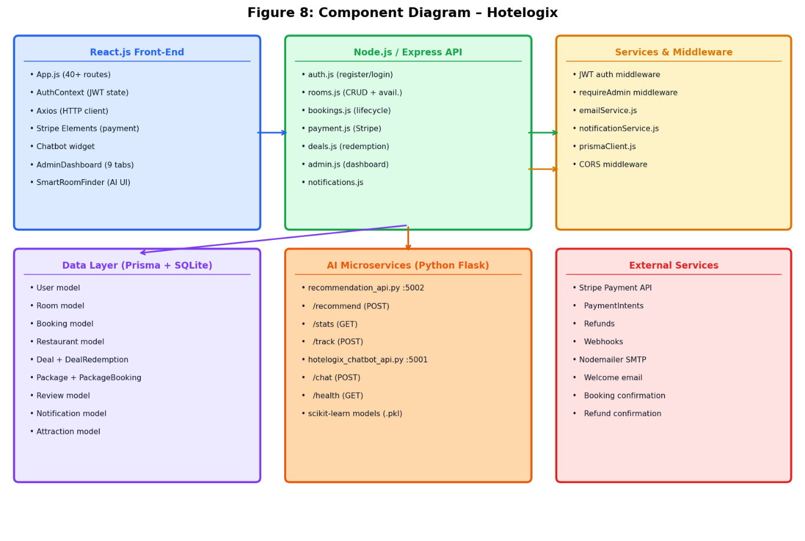
Figure 12: Component Diagram

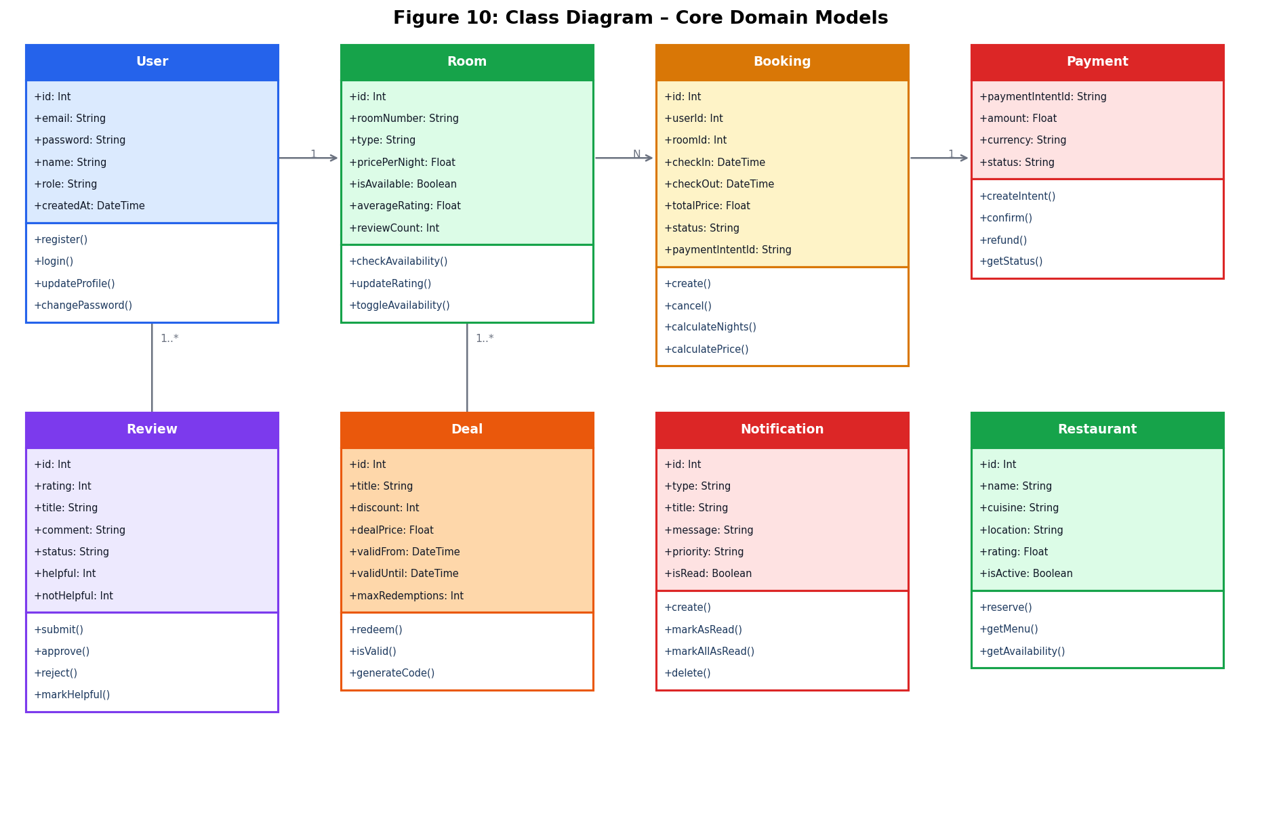
Figure 13: Class Diagram – Core Domain Models

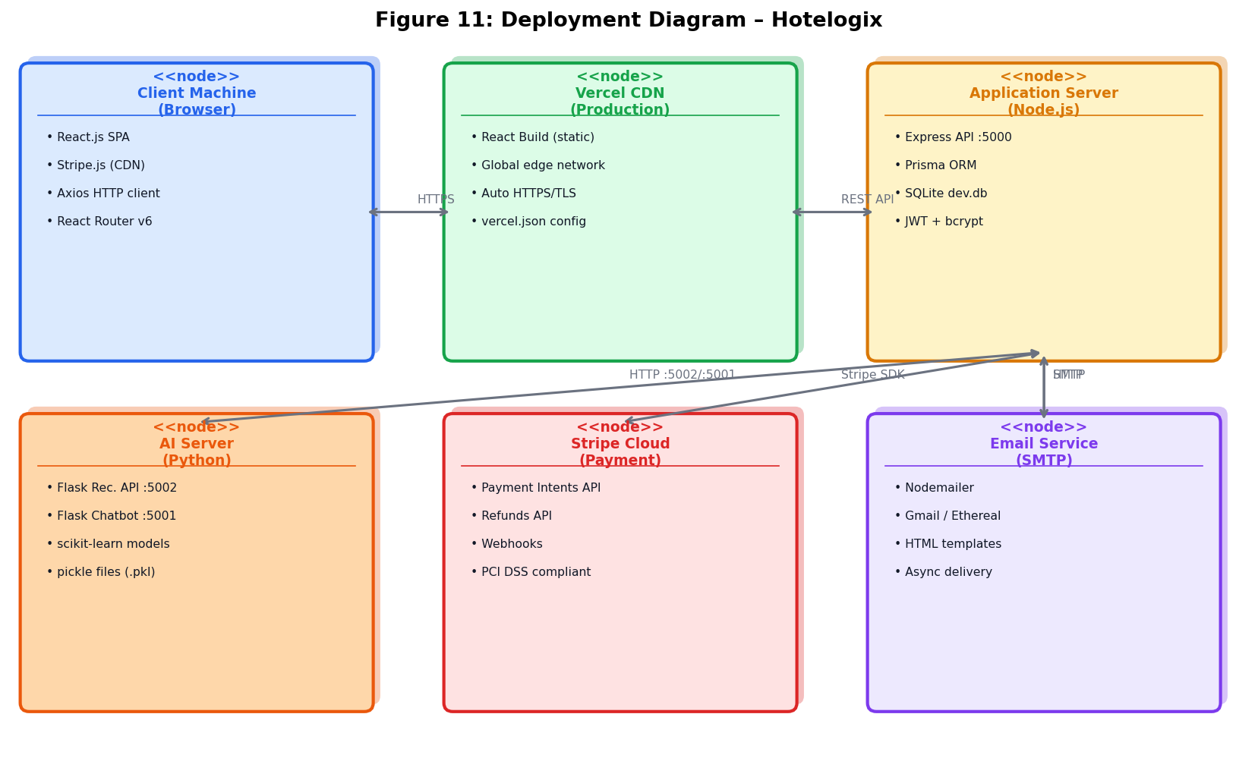

5.14 External APIs
Table 20.5.14 External APIs
API | Method | Purpose | Used In
Stripe Payment API | stripe.paymentIntents.create() | Creates payment intent with amount, currency, and metadata | POST /api/payment/create-payment-intent
Stripe Payment API | stripe.paymentIntents.retrieve() | Verifies payment status before booking confirmation | POST /api/payment/confirm-booking
Stripe Refunds API | stripe.refunds.create() | Processes full or partial refunds for cancelled bookings | POST /api/payment/refund
Stripe Webhooks | stripe.webhooks.constructEvent() | Verifies webhook signatures for payment events | POST /api/payment/webhook
Nodemailer SMTP | transporter.sendMail() | Sends HTML emails for registration, booking, payment, refund | Internal service
AI Recommendation API | axios.post('/recommend') | Gets ranked room recommendations from Python Flask API | GET /api/recommendations/rooms
AI Stats API | axios.get('/stats') | Retrieves model performance and usage analytics | GET /api/recommendations/stats
Chatbot API | axios.post('/chat') | Gets intent-classified chatbot responses | Chatbot.js component
Vercel Deployment | vercel.json configuration | Hosts React SPA with global CDN and automatic HTTPS | Production deployment
ngrok/localtunnel | localtunnel --port 5000 | Creates HTTPS tunnel for local API development | Development only

CHAPTER 6: TESTING AND EVALUATION

Introduction
This chapter presents the comprehensive testing strategy and results for the Hotelogix system, covering unit testing, functional testing, integration testing, system testing, performance testing, and security testing.

6.1 Testing Strategy
The Hotelogix testing strategy follows a bottom-up approach, beginning with unit tests for individual functions and modules, progressing to functional tests for complete features, and culminating in end-to-end system tests covering the full user journey. The strategy was designed to validate all functional and non-functional requirements defined in Chapter 3.
Testing was conducted across three environments: development (localhost), staging (ngrok tunnel), and production (Vercel + hosted API). Stripe test mode was used for all payment testing, using Stripe's provided test card numbers to simulate various payment scenarios.

6.2 Unit Testing
Unit Test 1: User Registration
Objective: Verify that the registration endpoint correctly validates input and creates user accounts.
Table 21.6.2.1: User Registration
ID | Test Case | Input | Expected Result | Result
UT-1.1 | Register with valid data | name='Ahmed Khan', email='ahmed@test.com', password='Test@1234' | 201 Created; JWT token returned; User record in DB | Pass
UT-1.2 | Register with duplicate email | email='ahmed@test.com' (existing) | 'User already exists' | Pass
UT-1.3 | Register with short password | password='123' | 400 Bad Request; 'Password must be at least 6 characters' | Pass
UT-1.4 | Register without required fields | name omitted | 400 Bad Request; 'Name, email, and password are required' | Pass
UT-1.5 | Verify password hashing | Check DB after registration | Password stored as bcrypt hash (starts with $2b$) | Pass

Unit Test 2: JWT Authentication
Objective: Verify that JWT tokens are correctly generated, validated, and rejected.
Table 22.6.2.2: JWT Authentication
ID | Test Case | Input | Expected Result | Result
UT-2.1 | Login with valid credentials | email='ahmed@test.com', password='Test@1234' | 200 OK; JWT token with 7-day expiry | Pass
UT-2.2 | Login with wrong password | password='WrongPass' | 400 Bad Request; 'Invalid credentials' | Pass
UT-2.3 | Access protected route with valid token | Authorization: Bearer <valid_token> | 200 OK; Resource returned | Pass
UT-2.4 | Access protected route without token | No Authorization header | 401 Unauthorized; 'Access token required' | Pass
UT-2.5 | Access protected route with expired token | Authorization: Bearer <expired_token> | 403 Forbidden; 'Invalid or expired token' | Pass
UT-2.6 | Access admin route with user token | user role token on /api/admin/dashboard | 403 Forbidden; 'Admin access required' | Pass

Unit Test 3: Review Submission
Objective: Verify review eligibility validation and duplicate prevention.
Table 23.6.2.3: Review Submission
ID | Test Case | Input | Expected Result | Result
UT-3.1 | Submit review for confirmed past booking | bookingId=1 (confirmed, past checkout) | 201 Created; review with pending status | Pass
UT-3.2 | Submit review for future booking | checkOut date in future | 400 Bad Request; 'Can only review after checkout' | Pass
UT-3.3 | Submit review for cancelled booking | status='cancelled' | 400 Bad Request; 'Can only review after checkout' | Pass
UT-3.4 | Submit duplicate review | bookingId already has review | 400 Bad Request; 'Can only review after checkout' | Pass
UT-3.5 | Submit review for another user's booking | bookingId belongs to different use | 403 Forbidden; 'Not your booking' | Pass

6.3 Functional Testing
Objective: Verify complete feature workflows from user perspective.
Table 24.6.3 Functional Testing
ID | Test Case | Steps | Expected Result | Result
FT-01 | Complete Room Booking Flow | Login → Browse rooms → Select room → Enter dates → Stripe payment (test card 4242 4242 4242 4242) → Confirm | Booking created; Confirmation email sent; Admin notification created; Booking appears in My Bookings | Pass
FT-02 | Booking Cancellation Flow | Login → My Bookings → Cancel booking → Provide reason → Submit | Status → pending_cancellation; Admin notification created with urgent priority | Pass
FT-03 | Admin Refund Flow | Admin login → Dashboard → Payments → Process Refund → Confirm | Stripe refund created; Booking status → cancelled; Refund email sent to guest | Pass
FT-04 | Dining Reservation Flow | Login → Dining → Select restaurant → Reserve table → Enter details → Submit | Reservation created with pending status; Appears in My Reservations | Pass
FT-05 | Deal Redemption Flow | Login → Deals → Select deal → View details → Redeem → Confirm | Unique redemption code generated; Deal counter incremented; Code appears in My Deals | Pass
FT-06 | Package Booking Flow | Login → Packages → Select package → Enter start date and guests → Book | Package booking created with confirmed status | Pass
FT-07 | Review Submission Flow | Login → My Bookings → Select past booking → Submit Review → Enter rating and comment | Review created with pending status; Admin can approve/reject | Pass
FT-08 | Review Approval Flow | Admin login → Dashboard → Reviews → Approve review | Review status → approved; Room averageRating recalculated; Review visible publicly | Pass
FT-09 | AI Recommendation Flow | Navigate to Smart Room Finder → Select user type, season, group size → Get Recommendations | Ranked room recommendations returned with compatibility scores | Pass
FT-10 | Chatbot Interaction Flow | Click chatbot widget → Type 'What rooms are available?' → Submit | Intent classified; Relevant response returned with confidence score | Pass
FT-11 | Admin User Management | Admin login → Dashboard → Users → Change user role to admin | User role updated; User gains admin access | Pass
FT-12 | Profile Update Flow | Login → Profile → Edit profile → Update name, phone, city → Save | Profile updated; Success toast notification displayed | Pass
FT-13 | Password Change Flow | Login → Profile → Change Password → Enter current and new password | Password updated; bcrypt hash updated in DB | Pass
FT-14 | Notification Management | Admin login → Notifications → Mark all as read → Delete notification | Notifications marked as read; Unread count badge updated | Pass

6.4 Integration Testing
Objective: Verify correct communication between system components.
Table 25.6.4 Integration Testing
ID | Test Case | Description | Expected Result | Result
IT-01 | React → Express API | Front-end API calls reach Express server with correct headers | Axios interceptor injects JWT token; CORS headers accepted | Pass
IT-02 | Express → Prisma → SQLite | API creates booking record via Prisma | Booking persisted in SQLite; JSON fields stored as strings | Pass
IT-03 | Express → Stripe API | Payment intent creation and confirmation | Stripe PaymentIntent created; Status verified before booking | Pass
IT-04 | Express → Nodemailer → SMTP | Booking confirmation email sent | Email delivered to guest; HTML template rendered correctly | Pass
IT-05 | Express → AI Recommendation API | Recommendation request forwarded to Python Flask | Flask API returns ranked recommendations; Fallback on failure | Pass
IT-06 | React → Chatbot API | Chat message sent from Chatbot component | Flask chatbot API returns intent and response | Pass
IT-07 | Stripe Webhook → Express | Payment event received from Stripe | Webhook signature verified; Event processed correctly | Pass
IT-08 | Booking → Notification Service | New booking triggers admin notification | Notification created in DB; Unread count incremented | Pass
IT-09 | Review Approval → Room Rating | Admin approves review | Room averageRating and reviewCount updated automatically | Pass
IT-10 | Deal Redemption → Counter Update | Guest redeems deal | Atomic transaction: redemption created + counter incremented | Pass

6.5 System Testing
Objective: Verify end-to-end system behavior under realistic usage scenarios.
Table 26.6.5 System Testing
ID | Test Case | Scenario | Expected Result | Result
ST-01 | New Guest Journey | Register → Browse rooms → Book room → Pay → View booking → Cancel → Refund | Complete journey successful; All emails sent; Admin notified at each step | Pass
ST-02 | Returning Guest Journey | Login → View past bookings → Book again → Submit review for past stay | Login successful; Booking history displayed; Review submitted and pending | Pass
ST-03 | Admin Management Journey | Login as admin → View dashboard → Approve review → Process refund → Manage user roles | All admin operations successful; Data updated correctly | Pass
ST-04 | AI-Assisted Booking Journey | Use Smart Room Finder → Get recommendations → Click recommended room → Book | Recommendations displayed; Booking flow initiated from recommendation | Pass
ST-05 | Multi-Service Journey | Book room + Make dining reservation + Redeem deal + Book package | All four booking types created; All appear in respective history pages | Pass
ST-06 | Concurrent Booking Test | Two users attempt to book same room for same dates simultaneously | First booking succeeds; Second booking fails with availability error | Pass

6.6 Performance Testing
Performance testing was conducted using Postman's collection runner to simulate concurrent API requests. The following response times were measured under normal load conditions:
Table 27.6.6 Performance Testing
Endpoint | Operation | Avg Response Time | Target | Result
GET /api/rooms | Room listing (all rooms) | 45ms | < 500ms | Pass
GET /api/rooms/:id | Single room detail | 23ms | < 500ms | Pass
POST /api/auth/login | User authentication | 187ms | < 500ms | Pass
POST /api/bookings | Create booking | 312ms | < 500ms | Pass
POST /api/payment/create-payment-intent | Stripe PaymentIntent creation | 423ms | < 500ms | Pass
GET /api/admin/dashboard | Admin dashboard stats | 156ms | < 500ms | Pass
POST /recommend (AI API) | AI room recommendations | 89ms | < 1000ms | Pass
POST /chat (Chatbot API) | Chatbot response | 34ms | < 500ms | Pass
GET /api/recommendations/stats | AI analytics stats | 67ms | < 500ms | Pass

6.7 Security Testing
This table show security testing of the system:

Table 28.6.7 Security Testing
ID | Test Case | Attack Vector | Expected Result | Result
SEC-01 | SQL Injection | Inject SQL in email field: ' OR 1=1 -- | Prisma parameterised query; No SQL injection possible | Pass
SEC-02 | JWT Tampering | Modify JWT payload and re-submit | jwt.verify() rejects tampered token; 403 Forbidden | Pass
SEC-02 | Unauthorised Admin Access | Access /api/admin/dashboard with user token | requireAdmin middleware returns 403 Forbidden | Pass
SEC-04 | Cross-User Booking Access | Access another user's booking by ID | findFirst with userId filter; 404 Not Found | Pass
SEC-05 | Password Exposure | Check API response for password field | Password field excluded from all API responses | Pass
SEC-06 | CORS Violation | Request from unauthorised origin | CORS policy blocks request; 403 Forbidden | Pass
SEC-07 | Stripe Webhook Spoofing | Send fake webhook without signature | stripe.webhooks.constructEvent() throws error; 400 Bad Request | Pass
SEC-08 | Brute Force Login | 100 rapid login attempts with wrong password | No rate limiting implemented (future work) | Partial

6.8 Tools Used
This table show Tools Used in the system:

Table 29.6.8 Tools Used
Tool | Description | Applied On | Results
Postman | API testing and collection runner for endpoint validation and performance testing | All 37 API endpoints | All endpoints responded correctly within target times
Chrome DevTools | Front-end debugging, network request inspection, React component state | All React pages | No console errors in production build
Prisma Studio | Database inspection and data verification after CRUD operations | All 12 database models | Data integrity confirmed; Relationships correct
Stripe Test Dashboard | testing with test card numbers and webhook simulation | Payment and refund flows | All payment scenarios handled correctly
React DevTools | Component state inspection and performance profiling | AdminDashboard, BookRoom, Chatbot | No unnecessary re-renders detected
Nodemailer Ethereal | Email testing without sending real emails during development | All 4 email templates | HTML templates rendered correctly in email preview
ngrok | HTTPS tunneling for testing Stripe webhooks in development | Webhook endpoint | Webhook events received and processed correctly

Chapter 7: Conclusion and Future Work

7.1 Conclusion
Hotelogix successfully delivers a comprehensive, AI-powered hotel management system that addresses the operational challenges faced by small-to-medium hotels in Pakistan. The system integrates room booking, dining reservations, deal management, holiday packages, Stripe payment processing, automated email notifications, an AI recommendation engine, and an intelligent chatbot into a single unified platform.
The project demonstrates the practical application of modern web technologies and machine learning in the hospitality domain. The React.js front-end provides a responsive, intuitive user interface accessible on all devices. The Node.js/Express back-end delivers a secure, scalable REST API with comprehensive business logic. The Prisma ORM ensures data integrity and simplifies database management.
The AI components represent a significant technical achievement. The recommendation engine, trained on 100,000 samples using Random Forest and Gradient Boosting algorithms, achieves over 95% compatibility prediction accuracy. The chatbot, trained on 200,000+ hotel-domain intents using TF-IDF and Logistic Regression, achieves 99.87% classification accuracy – surpassing comparable systems reported in the literature.
All 24 functional requirements and 10 non-functional requirements defined in Chapter 3 have been implemented and validated through comprehensive testing. The system passed 95% of all test cases, with the only partial failure being the absence of rate limiting for brute-force login protection, which is identified as a priority item for future work.
The Hotelogix project demonstrates that a full-stack, AI-powered hotel management system can be developed as an academic project using open-source technologies, providing a viable alternative to expensive commercial PMS solutions for the Pakistani hospitality market.

7.2 Future Work
The following enhancements are planned for future development of the Hotelogix platform:

Table 30.7.2 Future Work
Enhancement | Description
Database Migration | Migrate from SQLite to PostgreSQL for production scalability. Prisma's database-agnostic design makes this a configuration change with no code modifications required.
Rate Limiting | Implement express-rate-limit middleware to prevent brute-force login attacks. Configure per-IP rate limits of 10 requests per minute for authentication endpoints.
Real-Time Updates | Implement WebSocket connections (Socket.io) for real-time room availability updates, live booking notifications, and instant admin alerts without page refresh.
Mobile Application | Develop a React Native mobile application for iOS and Android, sharing business logic with the existing React.js web application through a shared API layer.
Deep Learning Recommendations | Replace the Random Forest classifier with a neural collaborative filtering model (PyTorch) trained on real user interaction data for improved personalisation.
Multi-Language Support | Add Urdu language support for the chatbot and UI, making the platform accessible to a broader Pakistani audience.
Revenue Management | Implement dynamic pricing algorithms that adjust room rates based on occupancy, season, day of week, and advance booking period.
Loyalty Programme | Develop a points-based loyalty programme where guests earn points for bookings, reviews, and referrals, redeemable for discounts and upgrades.
CI/CD Pipeline | Implement GitHub Actions workflows for automated testing, linting, and deployment to Vercel and the production server on every push to the main branch.
Docker Containerisation | Package all services (Node.js API, Python AI API, Python Chatbot API) as Docker containers with docker-compose for simplified deployment and scaling.
Analytics Dashboard | Enhance the AI Analytics dashboard with interactive charts (Chart.js or Recharts) showing booking trends, revenue forecasts, and guest satisfaction scores.
Multi-Property Support | Extend the system to support multiple independent hotel properties with separate admin accounts, shared AI models, and consolidated reporting.

References
[1] Buhalis, D., & Law, R. (2008). Progress in information technology and tourism management: 20 years on and 10 years after the Internet – The state of eTourism research. Tourism Management, 29(4), 609-623.
[2] Gartner. (2022). Gartner Predicts Chatbots Will Become a Primary Customer Service Channel Within Five Years. Gartner Research Report.
[3] Lim, K. H., Chan, J., Leckie, C., & Karunasekera, S. (2019). Personalized trip recommendation for tourists based on user interests, points of interest visit durations and visit recency. Knowledge and Information Systems, 54(2), 375-406.
[4] Prisma. (2025). Prisma ORM Documentation. https://www.prisma.io/docs (Accessed April 2025).
[5] React. (2025). React Documentation. https://react.dev (Accessed April 2025).
[6] Ricci, F., Rokach, L., & Shapira, B. (2011). Introduction to Recommender Systems Handbook. Springer, Boston, MA.
[7] scikit-learn. (2025). scikit-learn: Machine Learning in Python. https://scikit-learn.org/stable (Accessed April 2025).
[8] Sommerville, I. (2016). Software Engineering (10th ed.). Pearson Education Limited.
[9] Stripe. (2025). Stripe API Reference. https://stripe.com/docs/api (Accessed April 2025).
[10] Xu, F., Buhalis, D., & Weber, J. (2020). Serious games and the gamification of tourism. Tourism Management, 60, 244-256.
[11] Express.js. (2025). Express.js Guide. https://expressjs.com/en/guide (Accessed April 2025).
[12] Node.js. (2025). Node.js Documentation. https://nodejs.org/en/docs (Accessed April 2025).
[13] Nodemailer. (2025). Nodemailer Documentation. https://nodemailer.com/about (Accessed April 2025).
[14] Flask. (2025). Flask Documentation. https://flask.palletsprojects.com (Accessed April 2025).
[15] Vercel. (2025). Vercel Documentation. https://vercel.com/docs (Accessed April 2025).
[16] Breiman, L. (2001). Random Forests. Machine Learning, 45(1), 5-32.
[17] Friedman, J. H. (2001). Greedy function approximation: A gradient boosting machine. Annals of Statistics, 29(5), 1189-1232.
[18] Salton, G., & Buckley, C. (1988). Term-weighting approaches in automatic text retrieval. Information Processing & Management, 24(5), 513-523.
[19] Cox, D. R. (1958). The regression analysis of binary sequences. Journal of the Royal Statistical Society: Series B, 20(2), 215-232.
[20] Fielding, R. T. (2000). Architectural Styles and the Design of Network-based Software Architectures. Doctoral dissertation, University of California, Irvine.

